EEA AND NORWAY GRANTS
MULTISITE
BASIC TRAINING GUIDE 2025

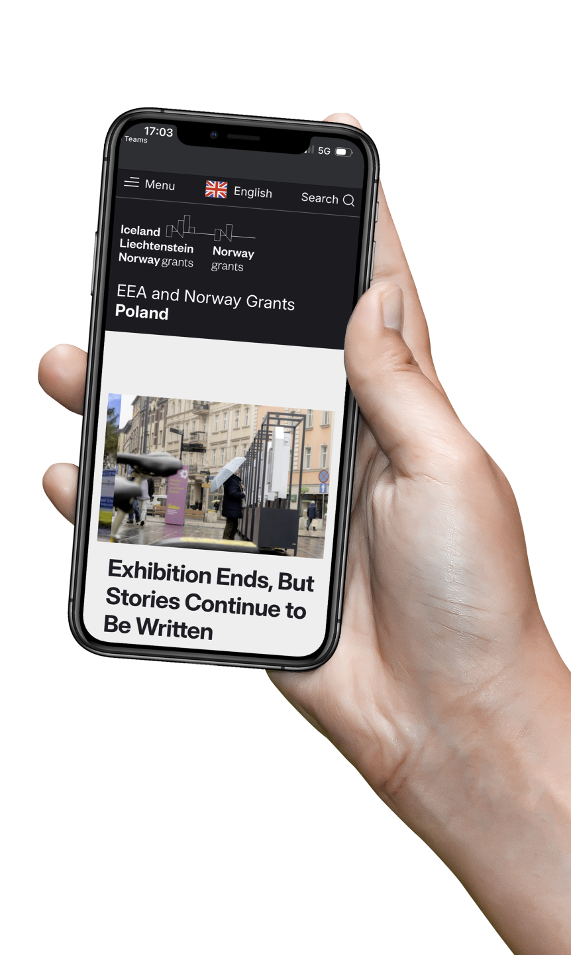

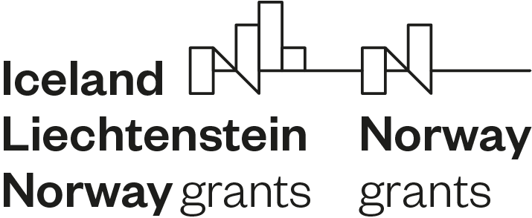

1. HOW TO LOG IN TO YOUR WEBSITE 6
2. HOW TO ADD A NEWS ITEM 10
3. HOW TO TRANSLATE AN ARTICLE 19
4. HOW TO EDIT IMAGE INFORMATION (captions, authors, alt text, etc.) 21
1. HOW TO ADD AN EVENT 23
2. HOW TO CREATE A PAGE 33
3. HOW TO ADD ITEMS (PAGES, etc) TO YOUR THE MENU 36
7. ADD DOCUMENTS TO YOUR LEGAL FRAMEWORK 40
8. HELP AND SUPPORT 50

HOW YOUR WEBSITE WORKS – THE BASICS

Your website is part of a larger shared system used by all EEA and Norway Grants countries.
This shared system is built on a platform called Drupal.

What is Drupal?
Drupal is the tool that powers your website.
It’s a content management system (CMS), meaning you don’t need to know any code to use it. You can log in, add pages, news articles, or documents, and translate your content easily. Think of Drupal as the engine that runs all our websites, the part that makes everything work behind the scenes.

GROUPS – How the platform is organised
All our websites are hosted on one shared system, called the Multisite.
Within it, there are different Groups — one for each level of the EEA and Norway Grants structure:

- FMO (Financial Mechanism Office) – manages and maintains the overall platform and shared content.
- NFPs (National Focal Points) – manage their national websites.
- POs (Programme Operators) – manage programme pages and related content, placed under the NFPs websites.
- FOs (Fund Operators) – manage specific fund pages.

Each group only sees and edits its own content. This keeps the structure clear and organised while allowing everyone to manage their own information.

Content and translations
Every piece of content you create on your website, for example, a news article, a page, or a call, is called a “node” in Drupal.

Each node can exist in several languages (usually English and your national language).
You can imagine this like a two-sided coin:
- It’s one single piece of content,
- but it shows one language or the other, depending on what the visitor selects on the site.

When you create or edit a page or article:
- You start with one language
- then you click Translate to add the other version,
- Drupal automatically shows the correct version depending on the site’s language.

This is how the entire website works, one shared structure, two languages always connected.

Automatically imported content (from GrACE)
Some information on your website comes automatically from GrACE, the grants management system.
This means you don’t have to upload these parts manually, they appear automatically and stay up to date.

The content that comes directly from GrACE includes:

- Legal documents in English– such as MoUs, Programme Agreements, Implementation Agreements, and Regulations (shown in the Legal framework section of your site).
- Calls for proposals (descriptions and documents) – published in both English and your national language.
- Project and Bilateral Initiative information – only project descriptions from GrACE, published in both English and your national language.

 | So if you see this content on your site, you don’t need to change or update it, it’s all handled automatically.

Content you can add yourself
As content owners, you have full control over your own communication materials.
You can add and update:
- News and articles
- Pages (for example, About, Contact, or any new page you need)
- Local documents (guides, publications, translated materials, etc.)

Images and the Media Library

The platform includes a shared Media Library.
This is where you can store and reuse images across the entire multisite.
When you add a picture (for example, to a news article), you have two options:

- Use an image from the Media Library – for example, a shared image already uploaded by the FMO or your team.
- Upload a new image – you can upload it directly to the Media Library or just attach it locally to one specific page or article.

The Media Library makes it easy to reuse visuals without having to upload the same file multiple times.

Difference between a basic page and a landing page

Most pages that you add and/or edit are going to be basic pages, like About or Contact us, that has simple title and body fields where you can add what content you want.

Landing pages are a different kind of content item that are used for some specific pages. The most complex is the homepage with all its different blocks, but Landing pages are also used for the pages that list other content item types like the news, events, calls, projects, programmes and documents (like legal framework) lists.

You see what type of content item you are dealing with at the top of the page when you edit:
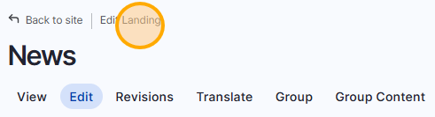

...or in the list of all your content, where you also can filter and order by content type:

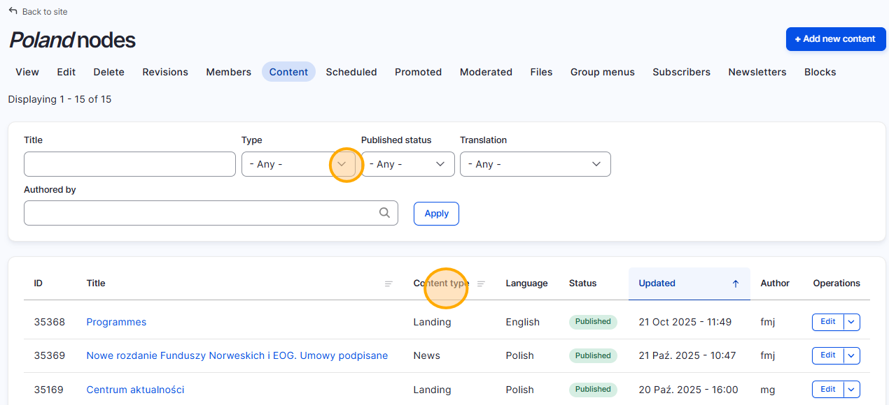

IN SHORT

- The system is built on Drupal, a simple, secure, and user-friendly tool.
- Each level (FMO, NFP, PO, FO) works in its own Group within the platform.
- Content (nodes) can be easily translated into multiple languages — like flipping a coin between English and your national language.
- GrACE automatically sends key legal documents, calls, and project information to your site.
- You manage pages, news, and local documents yourself.

  - HOW TO LOG IN TO YOUR WEBSITE

 | Learn how to access your national website on the EEA and Norway Grants multisite platform, using the credentials sent to you by email.

Before you can start adding or translating content, you’ll need to log in to the platform.
Each user (FMO, NFP, PO, FO) receives personal login credentials that provide access only to their own site and content.
1. Check your email for your credentials
You will receive an email from the FMO with:
- Your username (usually the first letter of your first name and the two first letters of your last name),
- A link to the login page
If you haven’t received it yet or can’t log in, contact the FMO communication team for support.
2. Go to the login page
Log in using this page:
https://eeagrants.org/en/user/login
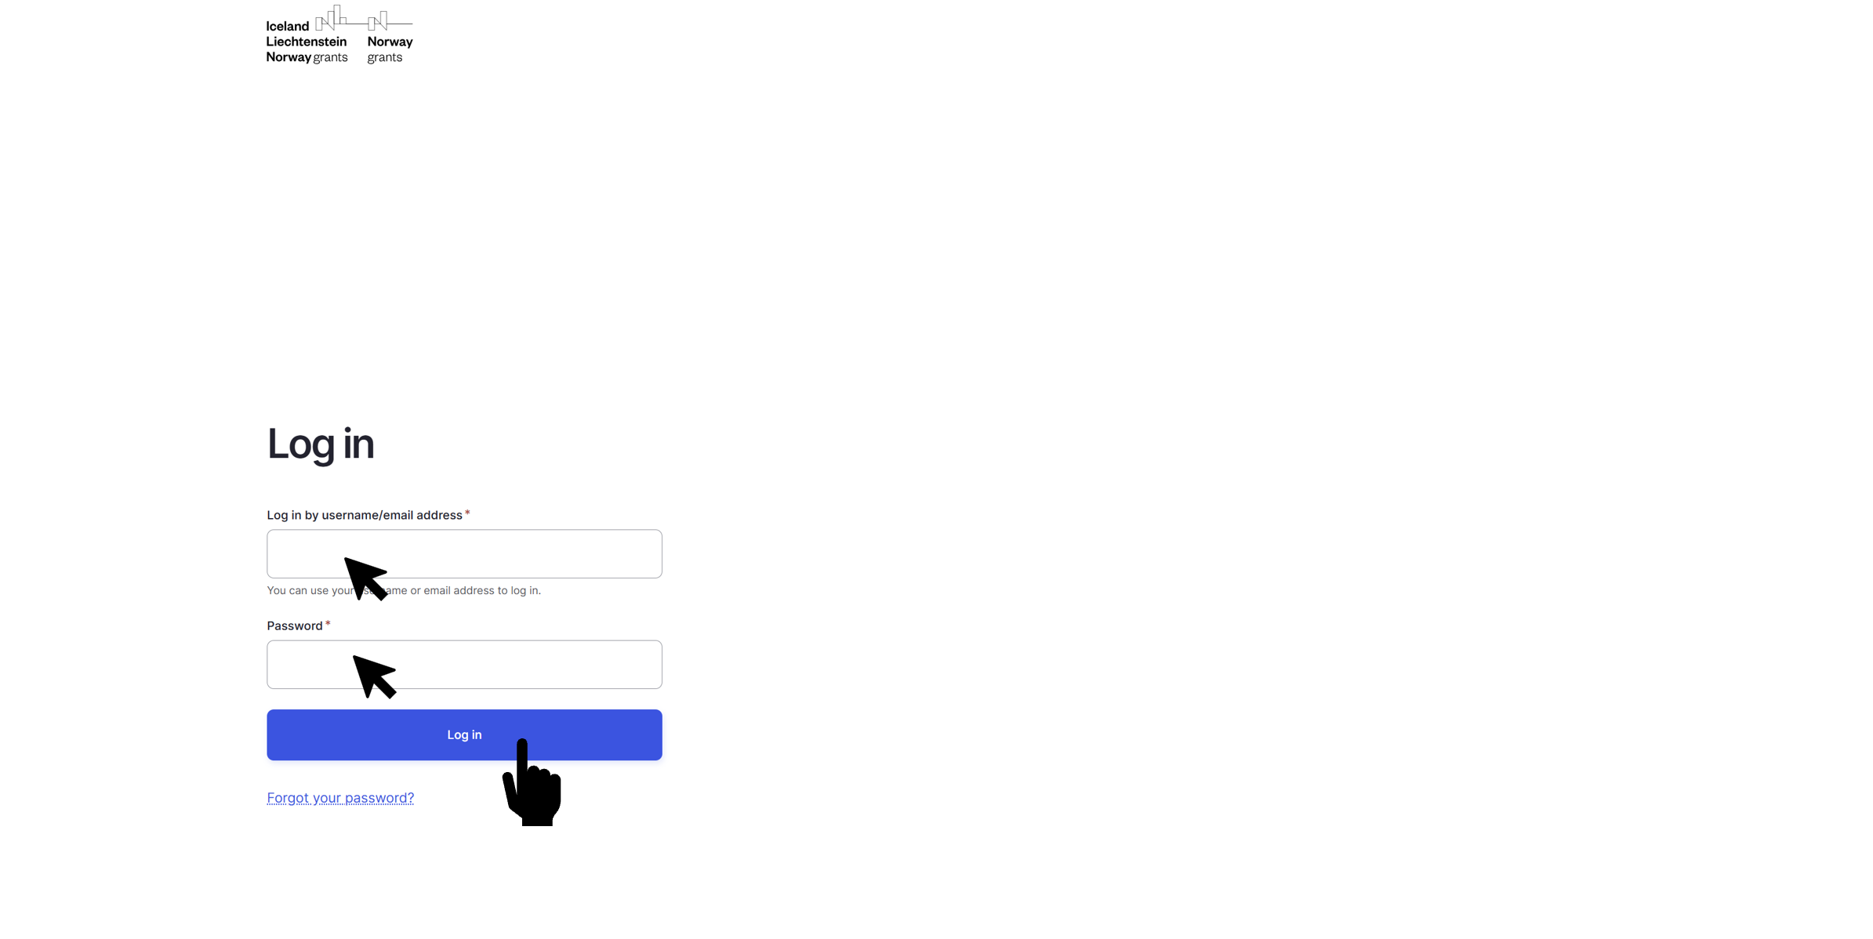
If this is your first time logging in, the system may ask you to change your password.
Choose one that is secure and easy to remember.
3. Read the disclaimer
Before logging in, you will see a short disclaimer. Please take a moment to read it carefully, it explains the terms of use for the platform, including responsibilities for managing and publishing content.
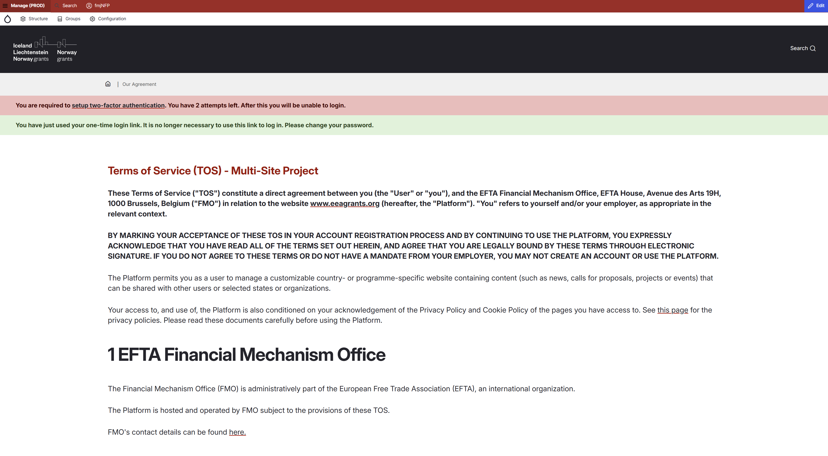
You must agree to the disclaimer to continue to your dashboard

CONGRATS, YOU’RE IN!
After logging in successfully, you’ll arrive at your dashboard.
From here, you can:
- Create or edit pages and news,
- Translate content,
- Upload images and documents,
- Review your published items.

If you see the message “Access denied,” it usually means your permissions haven’t been set yet, contact the FMO team and we’ll fix it quickly.

Once you’re logged in you need to navigate to your group (that’s your website’s location in the system). You will see this screen

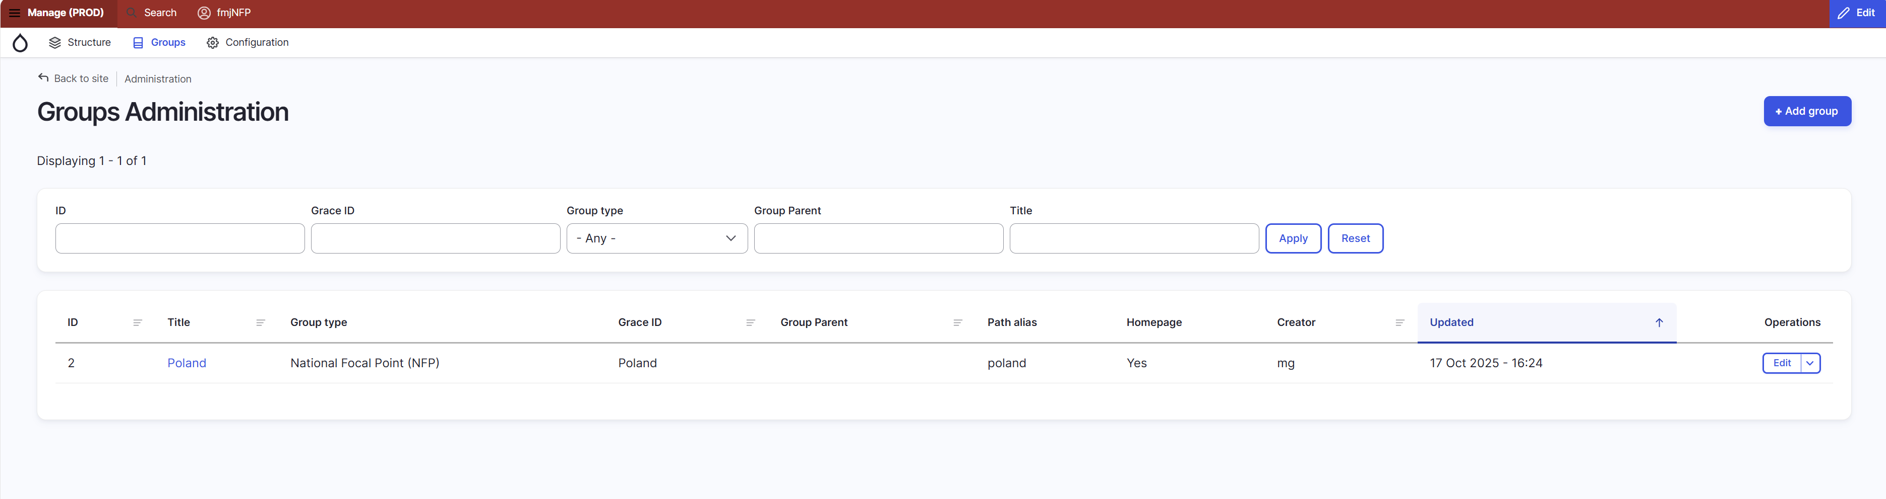Choose your group in the drop-down menu. 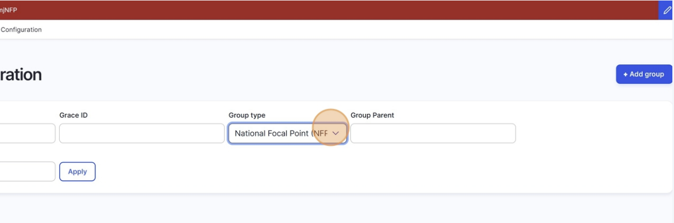Click on apply
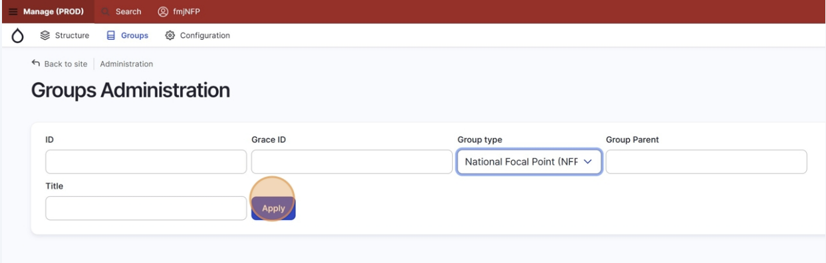

You will then see your website listed. Click on edit on the right, and you will now access your website’s content.
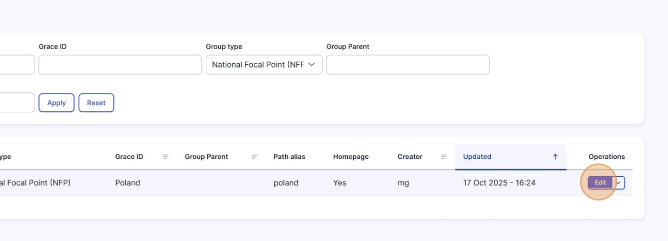
And from there, you can navigate to your site’s content (like news, pages, etc) by clicking on Content. More about adding content can be found in the next steps.
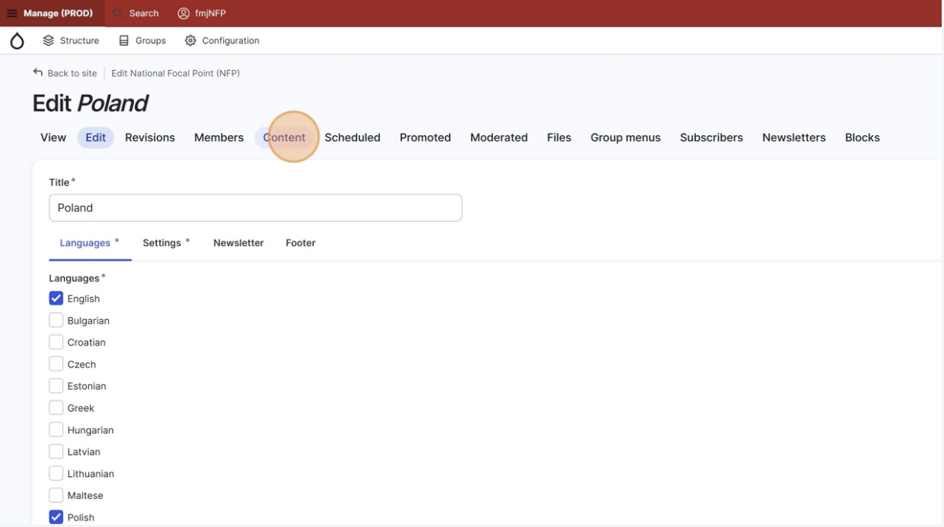

  - HOW TO ADD A NEWS ITEM

Create and publish a new
article on your site.

- Log in to your website (as seen in step 1) and make sure you are in the HOME tab
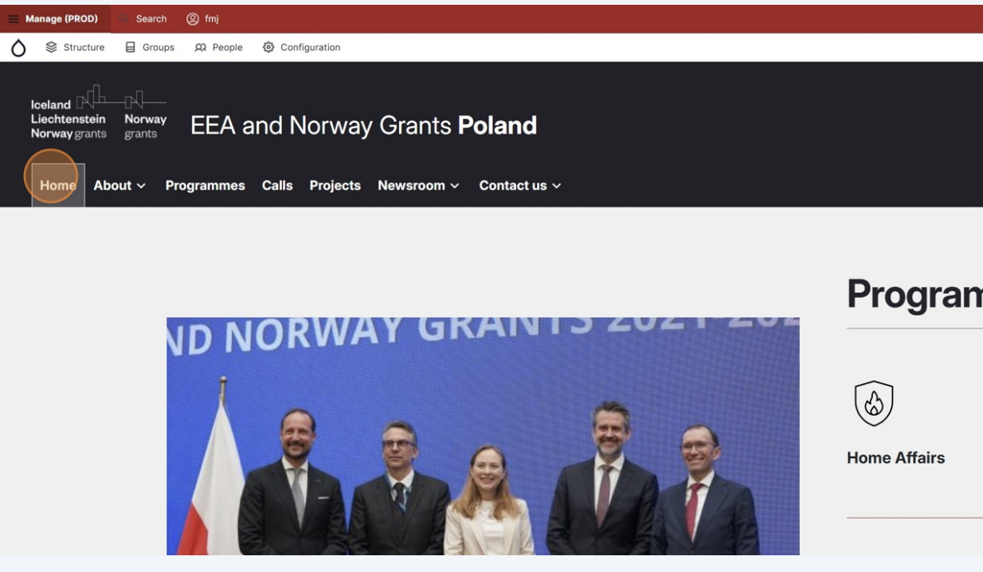
- On the right, click on CONTENT in the editing menu
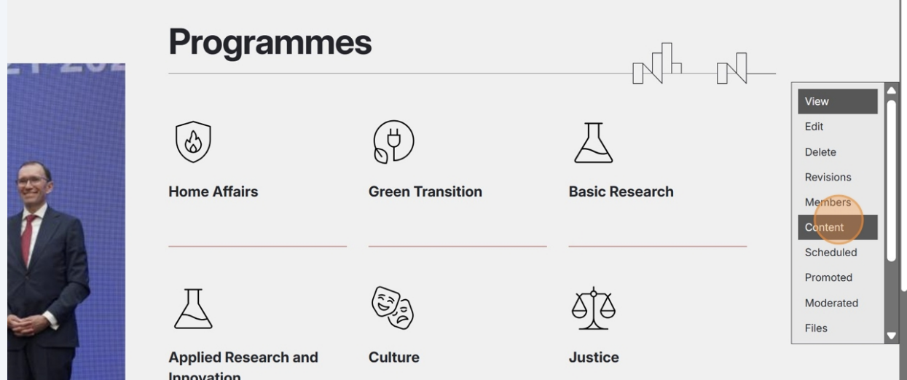

- In the top right, click on add new content
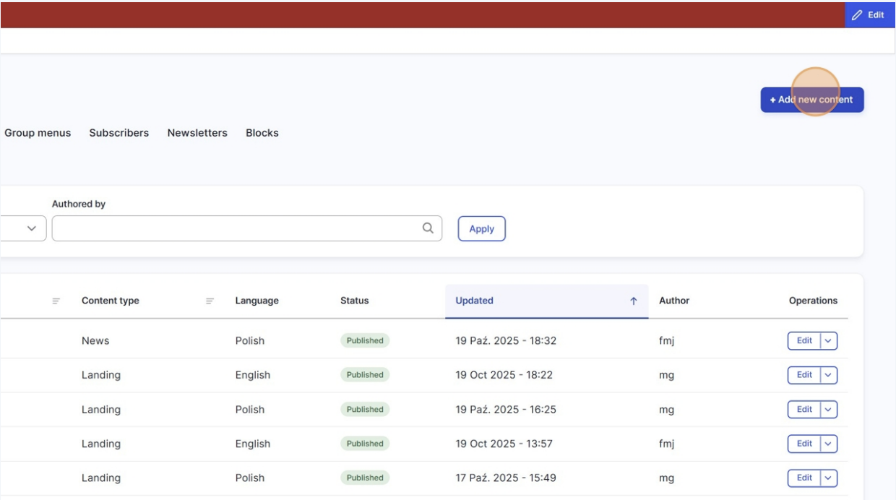
- Choose NEWS as the type of content you want to create

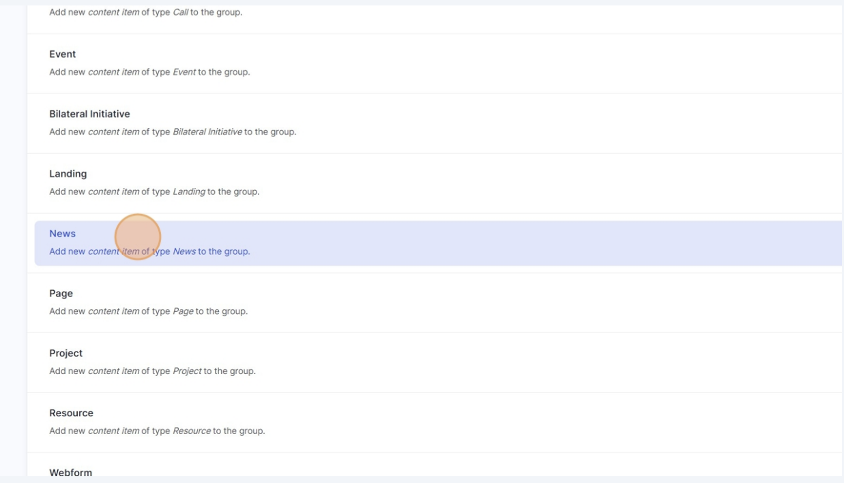

- Edit your news article
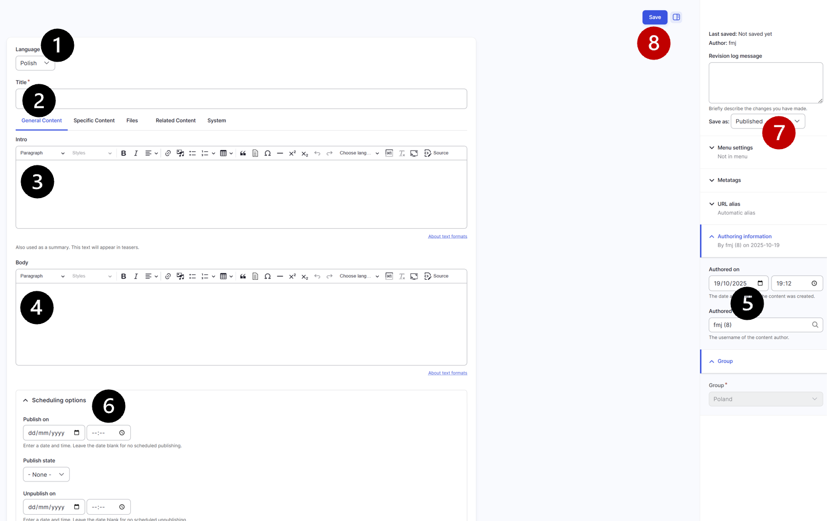
The News editing page provides all the tools you need to write, format, and manage your article, as well as control when and how it’s published.

- Current language
This area shows the language version you are currently working in. It becomes especially important once translations are added, as it helps you confirm which language version (English or national) you are editing.
- Title
Enter your news article title here. This is the main headline that will appear on the article page and in lists of news items.
- Introduction / Teaser
Write a short introduction to your article. This text appears on the Newsroom page as the teaser and may also appear on the homepage slider, if you choose to feature it there. The limit for the teaser, before it gets cut off, is 230 characters.
- Body (main content)
Add the main content of your article here. This is where you write your story and format it using the Content Editor tools (headings, text styles, links, quotes, etc.). Refer to the next section of this guide for detailed editing options.
- Publishing date
Here you can set the publication date of your article. By default, this is the current date and time, but you can change it to any past date if needed.
- Scheduling options
If you want to schedule your article, use this section. You can set a future publication date, define the publishing state, and optionally set a date to automatically unpublish the article later.
- Publishing status
Use this setting to define whether your article is Published, Draft, or Unpublished. Remember: changing this setting alone does not publish the article—you must still click Save for the change to take effect.
- Save
Click Save to store your article in its current state (draft, published, or scheduled). Always save before leaving the page to ensure your work is not lost.

- This is the editing field, where you write and format the main text of your page or article. The toolbar at the top gives you all the tools you need to style your content, for example, you can make text bold, italic, or underlined, add headings, create numbered or bullet lists, insert links, quotes, or images, and adjust text alignment. These tools work much like those in Word or Google Docs, so you can easily structure your text and make it clear and easy to read.

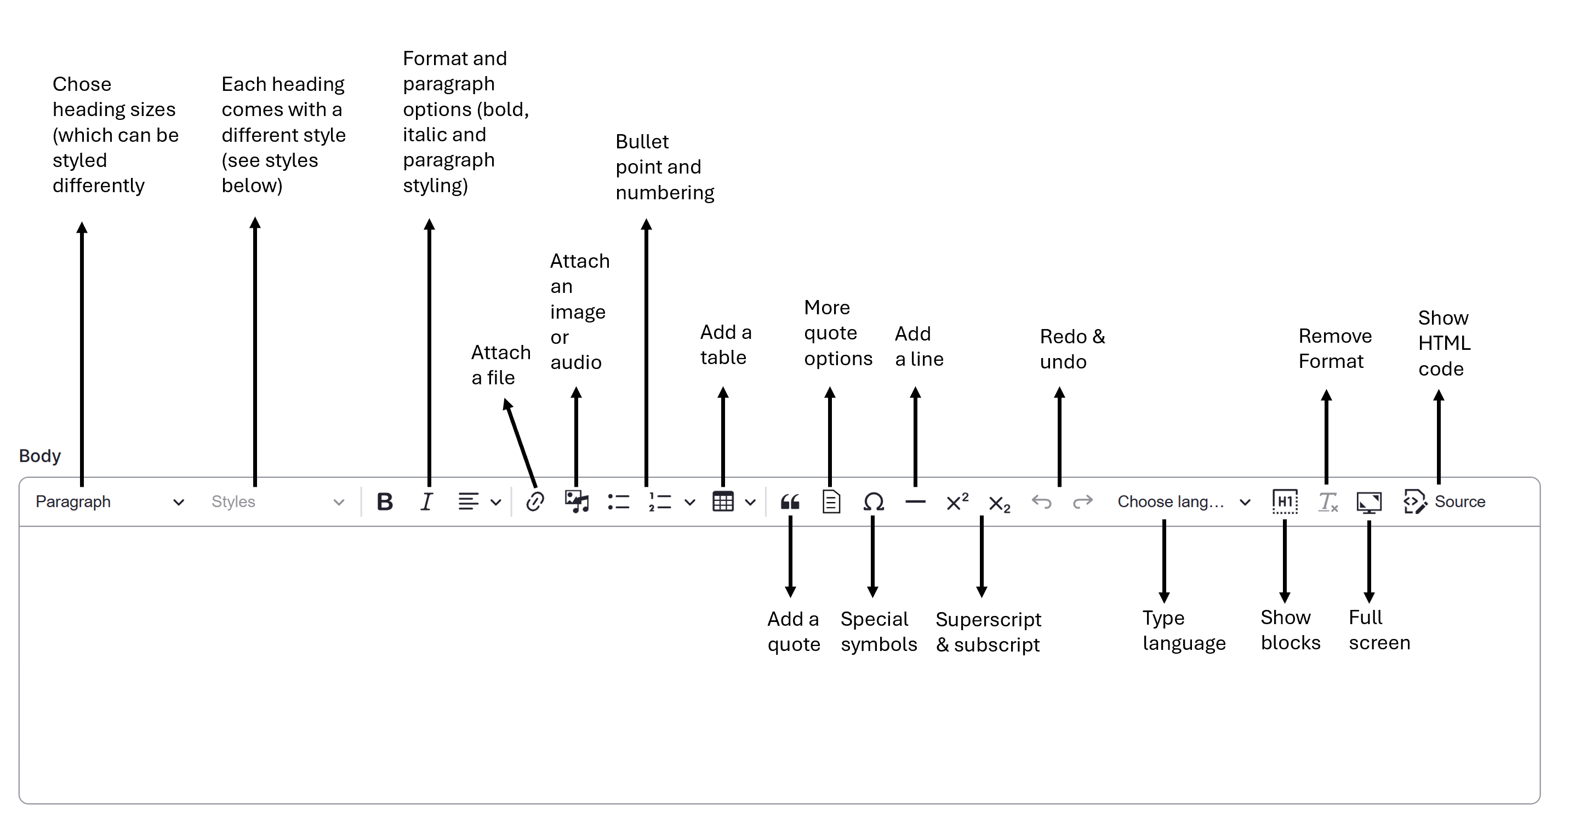

- You can use different headings in your articles.
If you add the corresponding ToC (table of content) style to your heading, it will appear in the table of content of your article

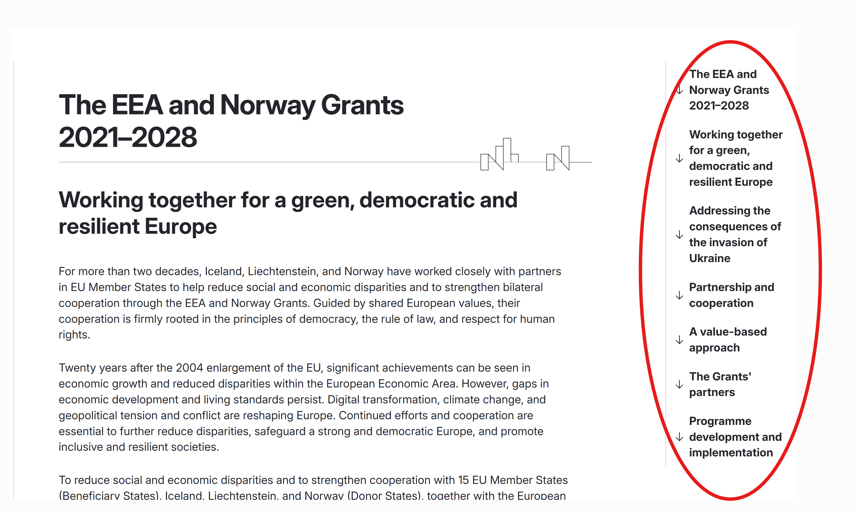

HEADING 2 ToC 2
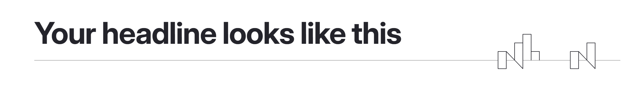
HEADING 3 ToC 3
HEADING 4 ToC 4
HEADING 5 ToC 5

- Add a main banner image to your article by clicking on files in the article editing options
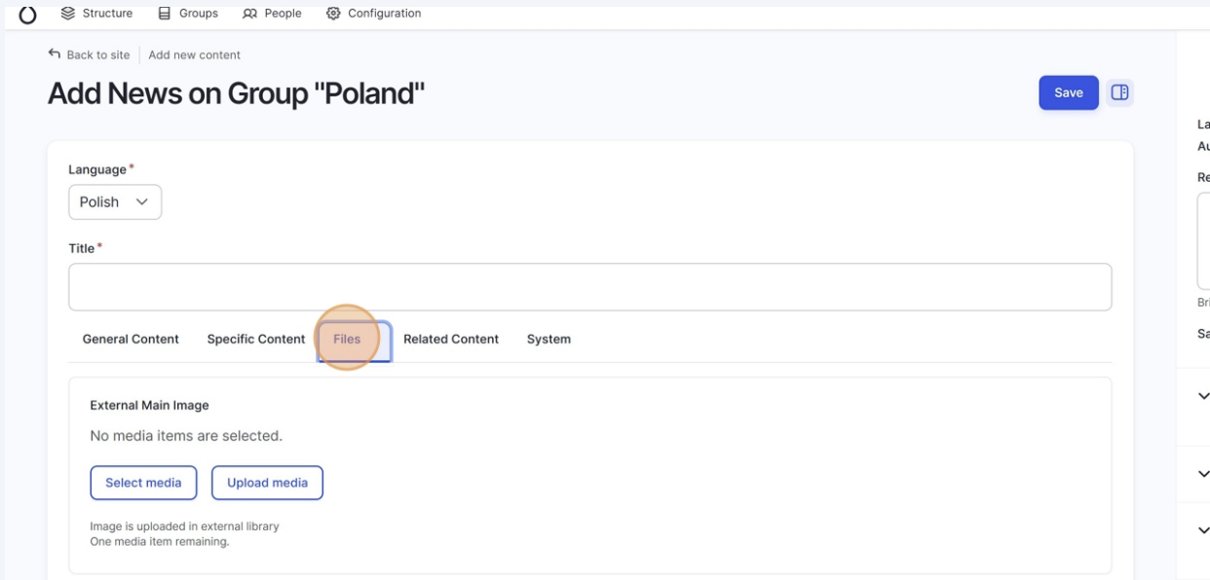

- Choose Local Main Image if you want to upload an image directly to your article (this image will only exist within Drupal, the website publishing tool). Choose External Main Image if you want to use an image from the Media Library, or if you’d like the image you upload to also be saved in the Media Library for future use.
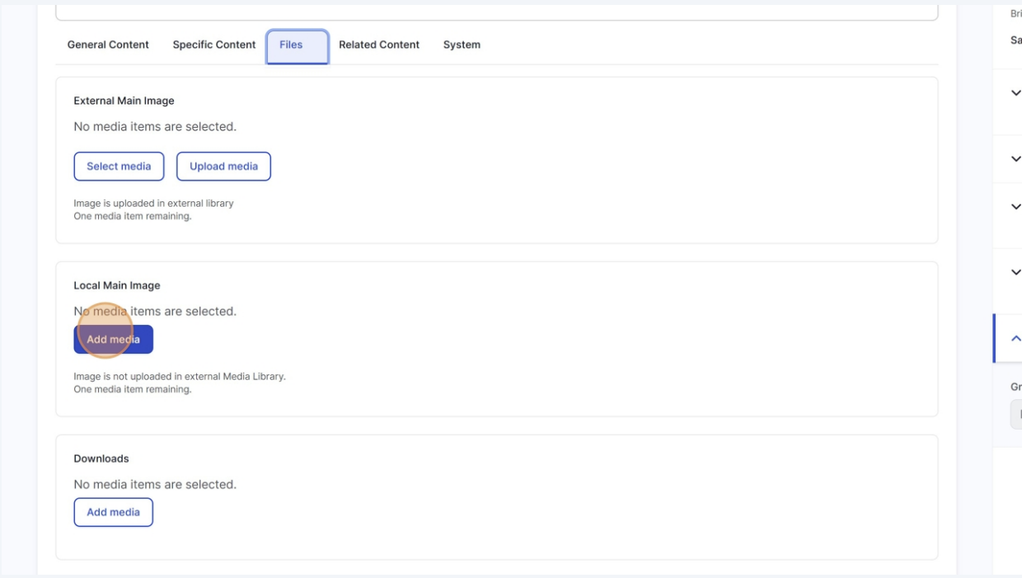
- Once you click on the Add media you will be presented with different options to either upload an image or select an image you have already uploaded to your website.

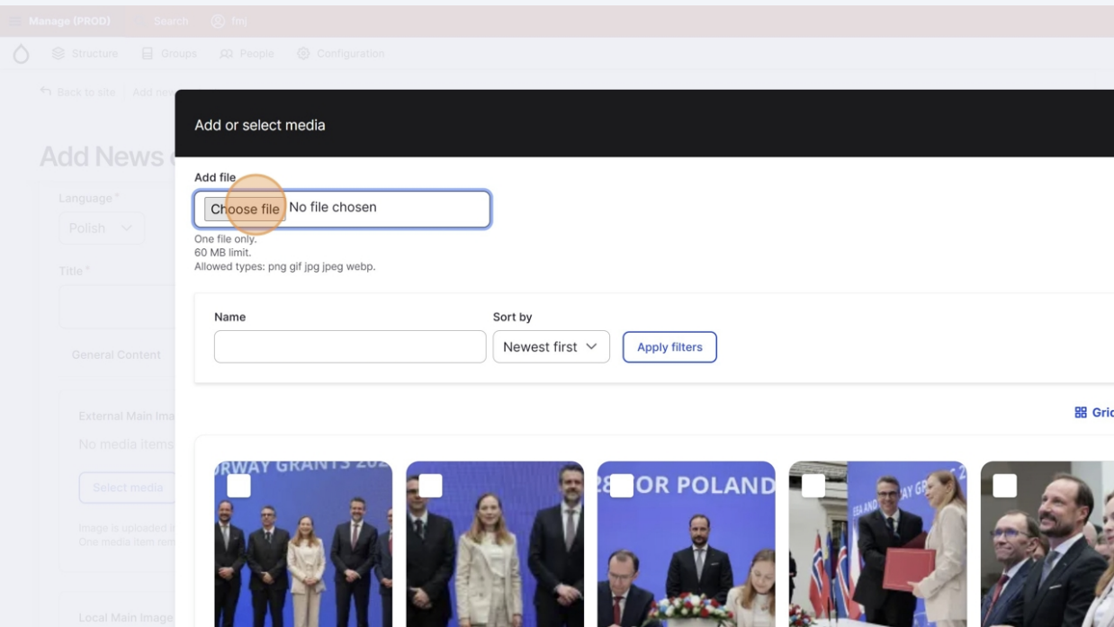

- Once you have either uploaded an image, or selected one you already had there, click on select.

- After you click Select, a small window will appear asking you to enter Alternative text.
This text helps Drupal organise and identify your image.

If you don’t edit it later, the alternative text you enter here will be displayed when the image is published. If you plan to translate the article and the image information (captions and alt texts), this text will later be replaced by what you add then. More on that in step 4.

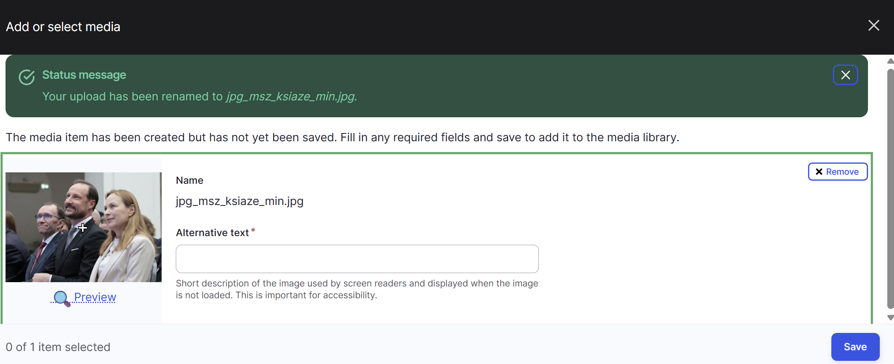

- Add an author to the article (this name will be shown at the top of the article, next to the publishing date

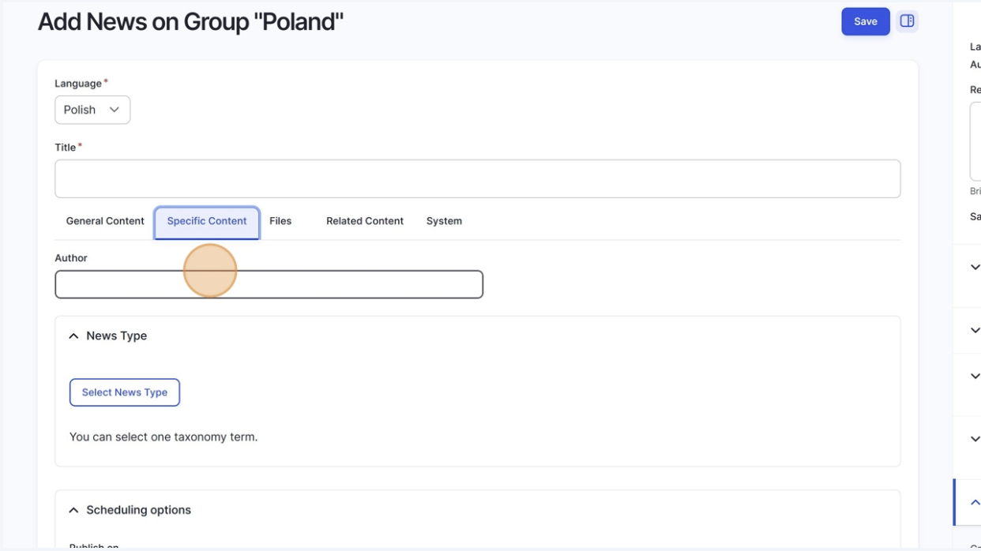

  - HOW TO TRANSLATE AN ARTICLE

- Once your article in your original language is saved, you will the option to Translate appear in menu on top of your page. Click on translate.

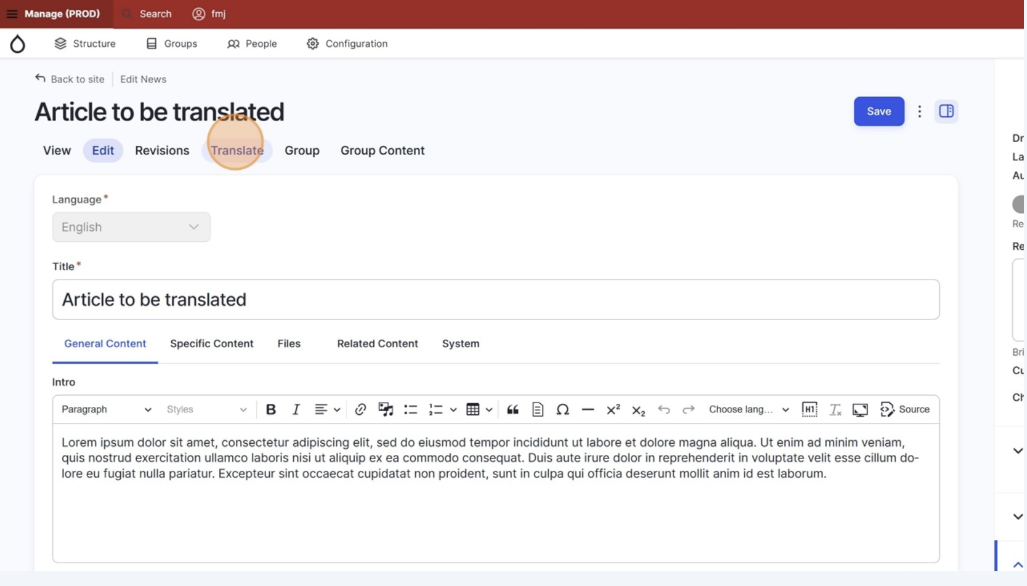
- Once inside the translation option, add the language you want to translate it to. Your site is set up in English and your national language, which means that can and should only translate your content into one of these two options.

Click on Add next to the target language.
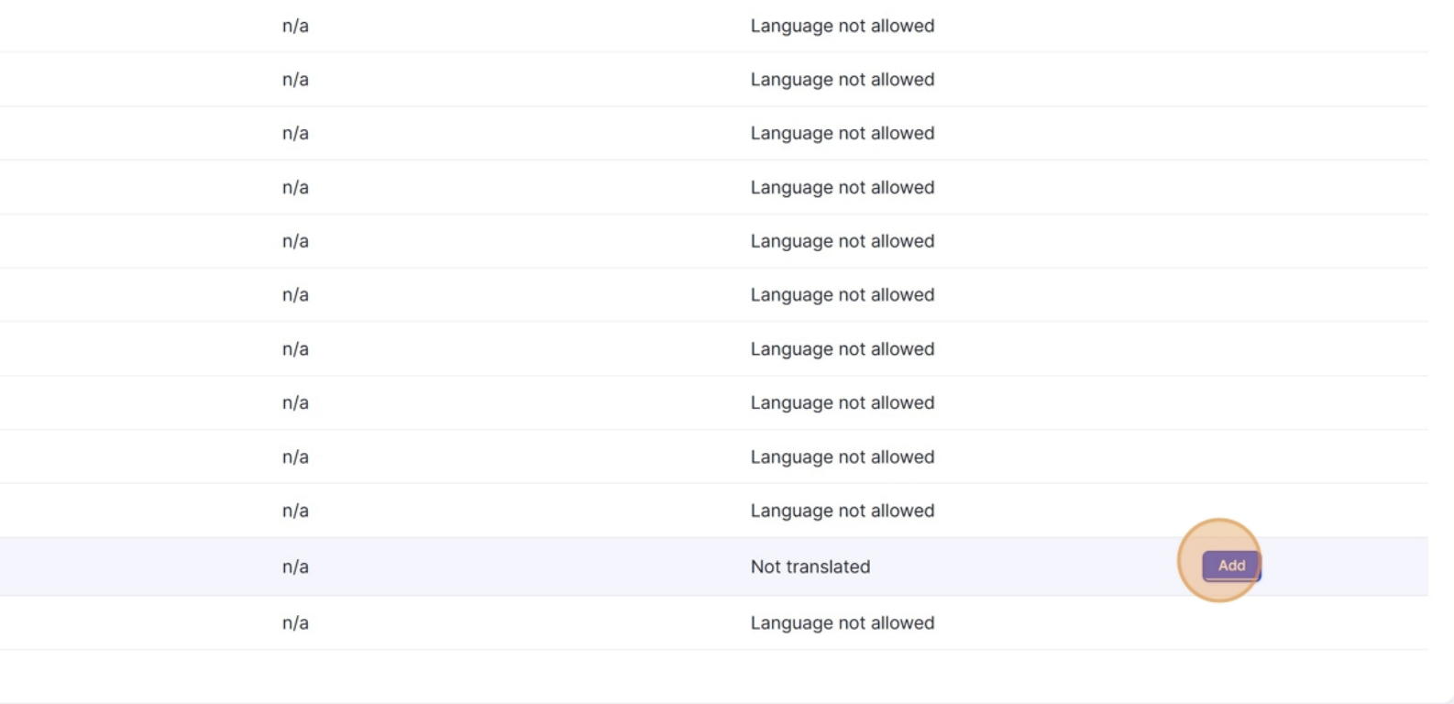
- Once you have clicked on add, you will be directed to the translated version of your content. Here you can replace the content with your translations. Pictures and files added to the article remain the same. Captions should also be translated on this page (see step 4 for that). Finalise the translation by clicking on Save (all translations)
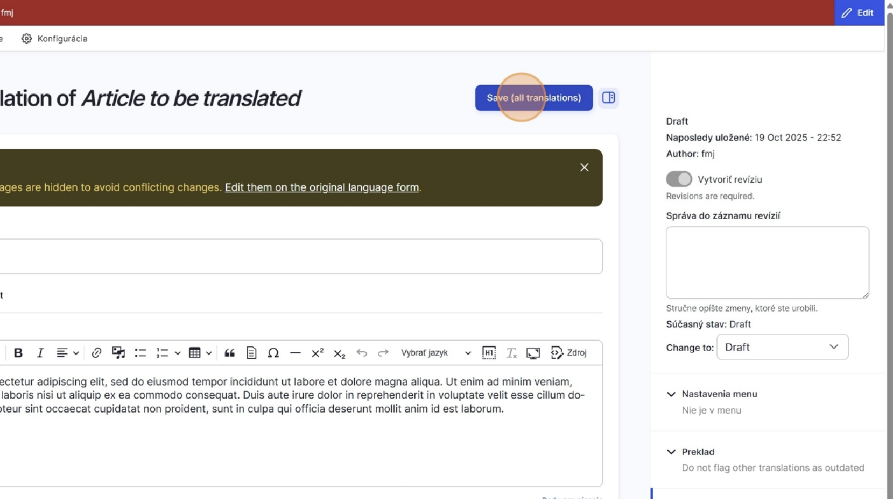
Translated versions are automatically displayed under the corresponding language on the website. If a translation is not available and a visitor switches the site’s language, the system will show the original version instead. For this reason, it is strongly recommended to translate all the content.
  - HOW TO EDIT IMAGE INFORMATION (captions, authors, alt text, etc.)

FOR DRUPAL

When you upload an image, Drupal will ask you to add Alternative text. This step is required — every image must have one.

The alternative text (also called alt text) is used to describe what appears in the image. It helps the Drupal system organise your files.

FOR VISITORS OF YOUR WEBSITE
You can update and translate it later by editing the image’s metadata directly from the frontend (view window)- that means from the published version of the page or article.

This ensures that users always see the alternative text, caption, author and copyright information in the correct language.

    - Click on Add Media metadata to edit the alt text of the image
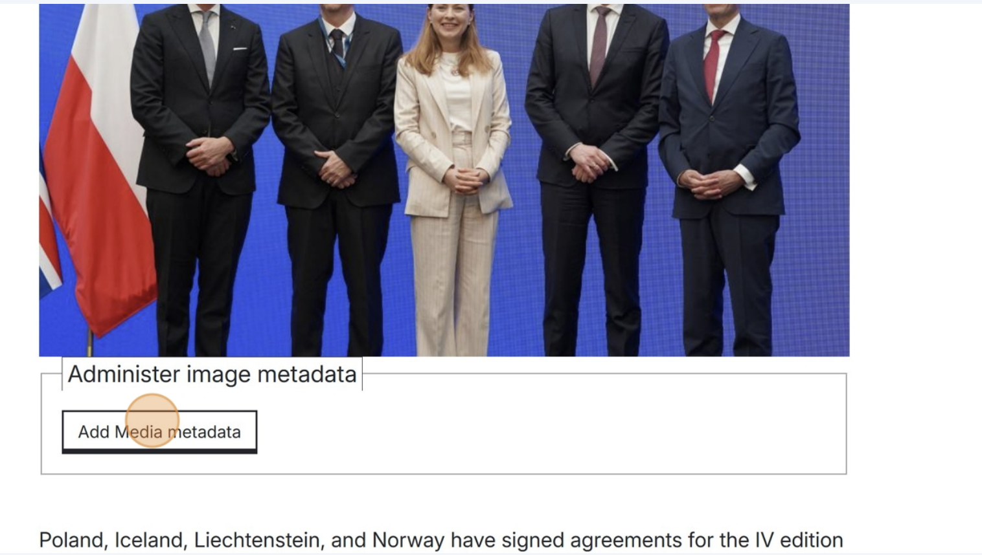
    - Add the alt text here (in the language of the article) and edit the other fields as you see fit.
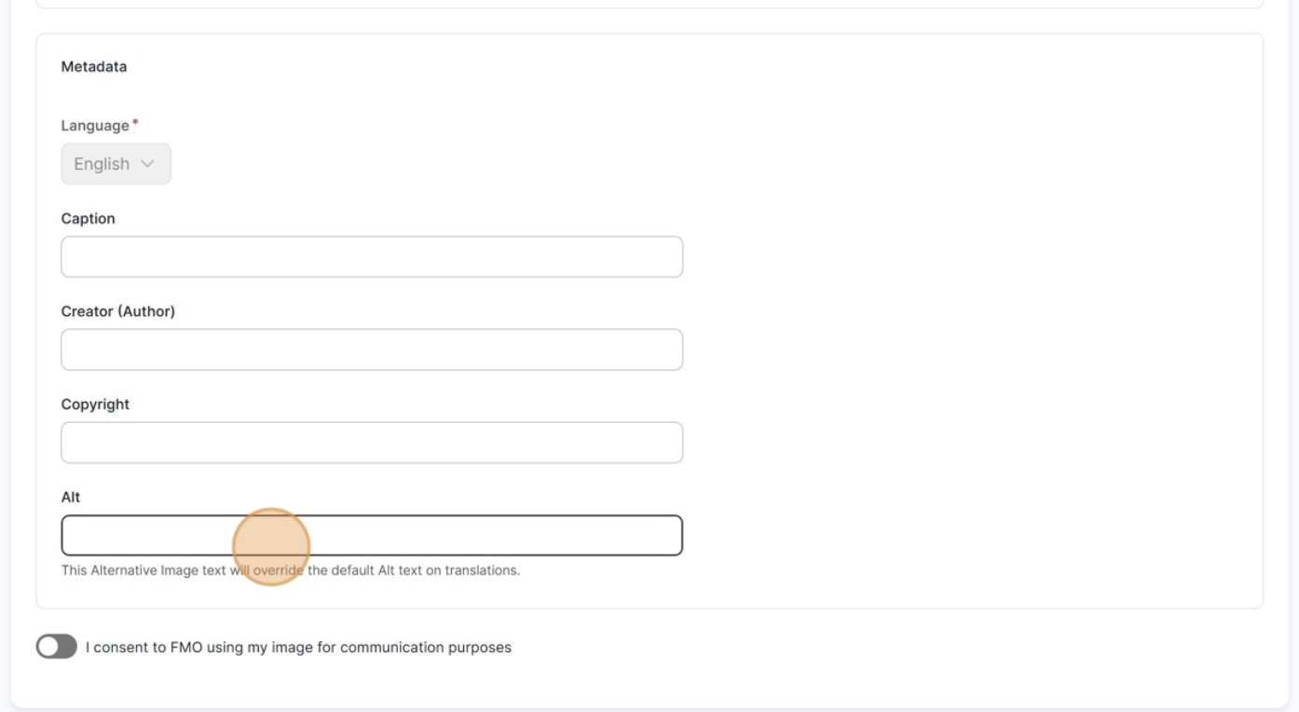
    - Click save. This information is now published with your image.

    - The captions, author, copyright and alt text information can also be translated, following the same approach as any other content on the website.

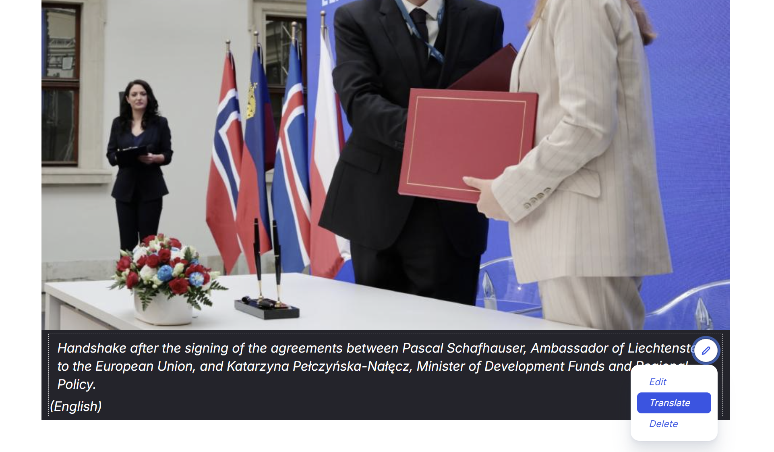

  - HOW TO ADD AN EVENT

Adding an event to your website is essential to showcase your country’s activities, promote visibility for your programmes, and keep your audience informed about key milestones such as call launches, conferences, partnership meetings, and project events. Events help illustrate the ongoing work supported by the Grants and make your national website feel active and up to date.

  - To add an event, go to the content tab in your dashboard.
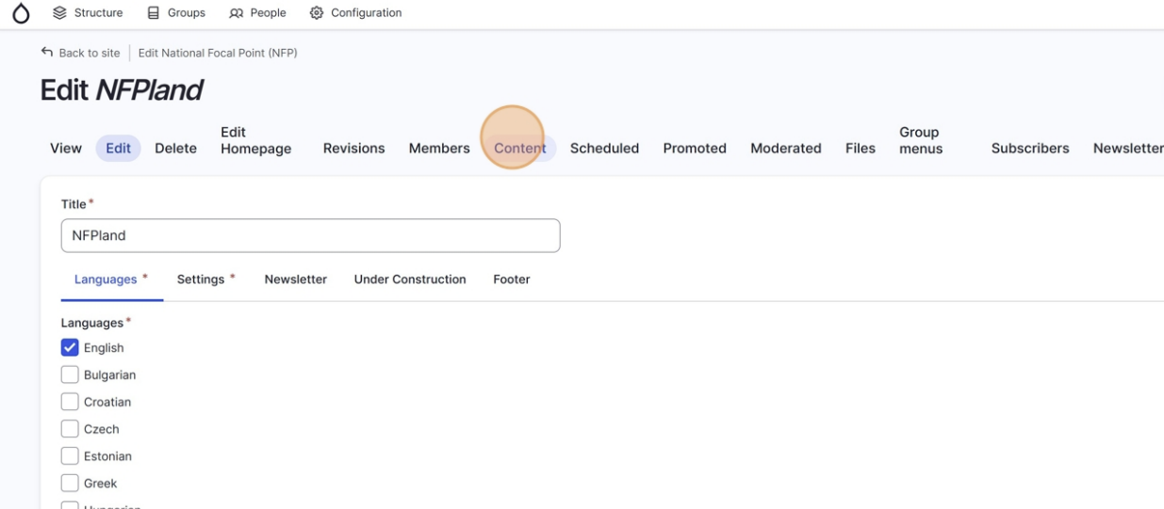
  - Click on Add new content
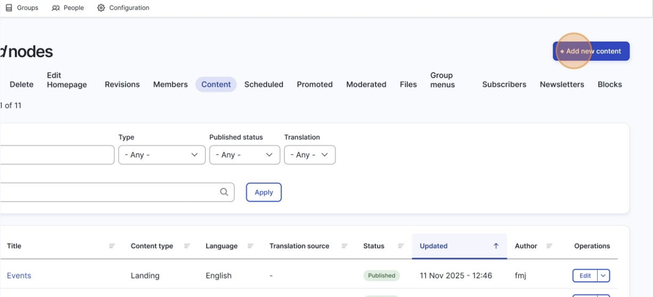

  - Click on Event in the list
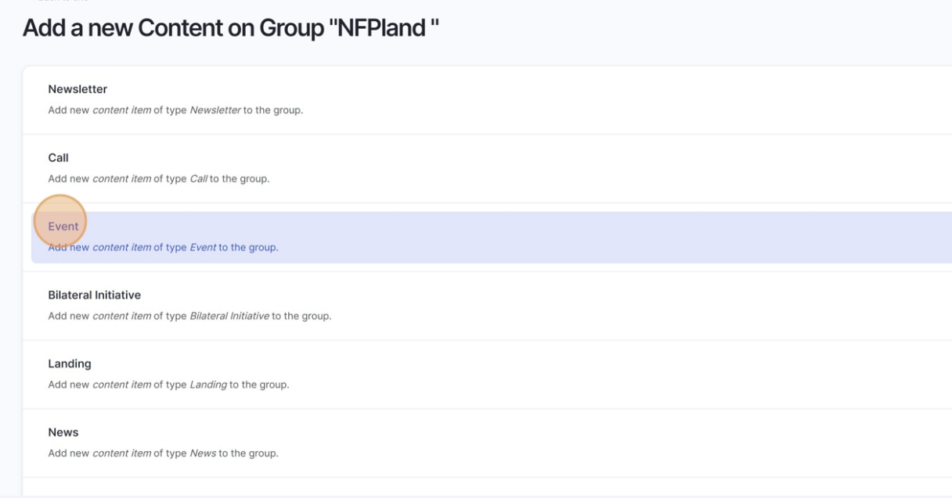
  - Now you will add the details of your event. Add a title first.

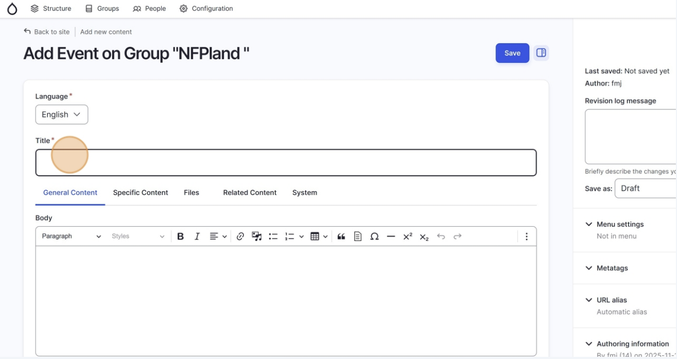

  - Then a description for your event.
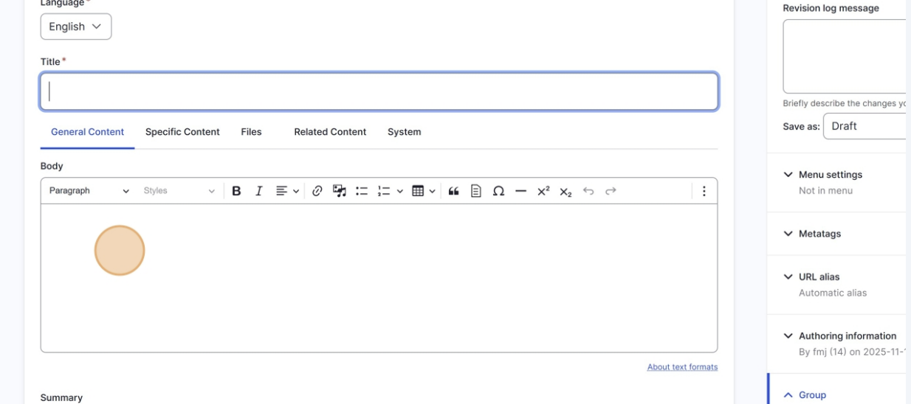
  - Then a summary for your event (this is a short sentence shown next to your event when presented in a list of events on your website). The full description will only be seen by your readers if they click on the event itself.

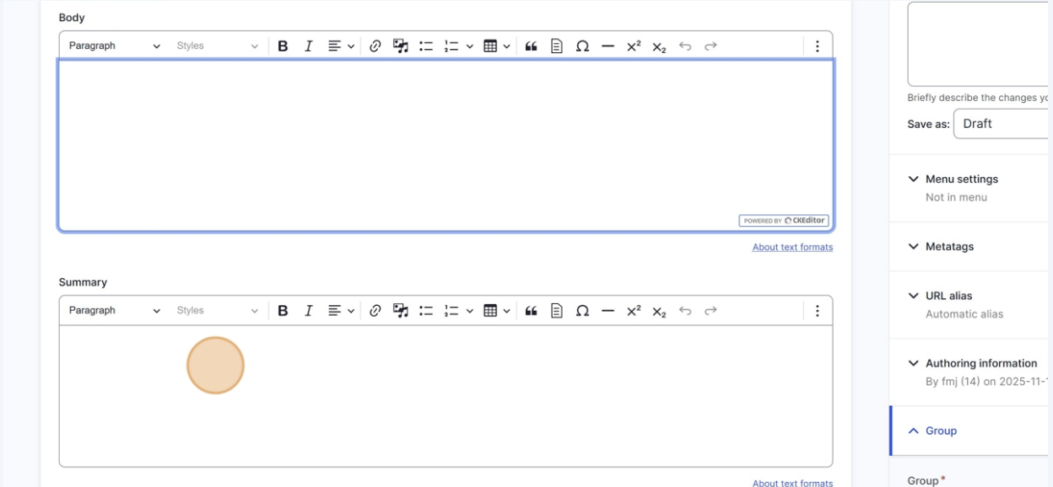

  - Now you will add the specific information related to your event (location, dates, times, and types of events). Navigate to the Specific Content tab.
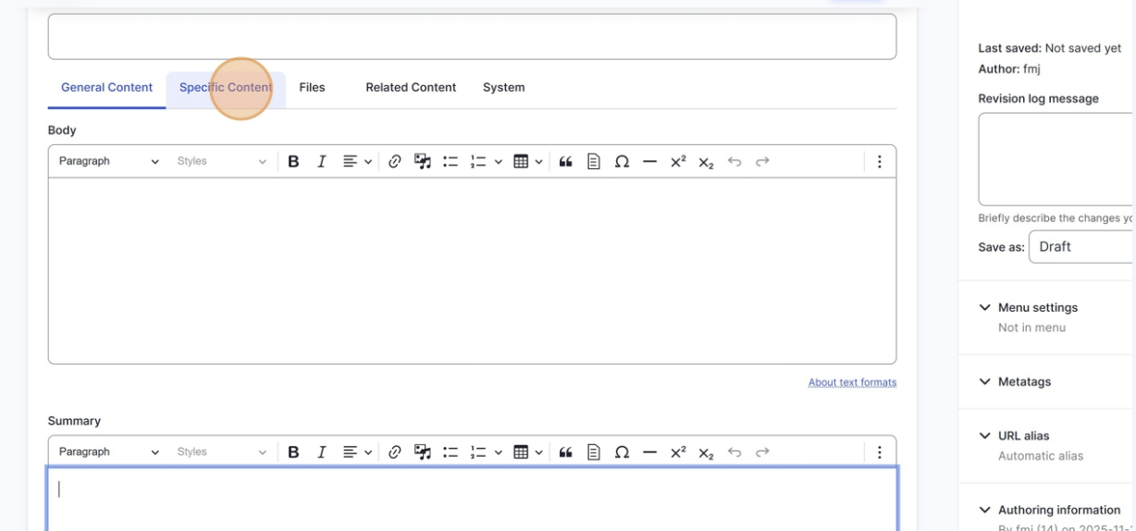
Let’s start with the event type. Click on Select Event Type.

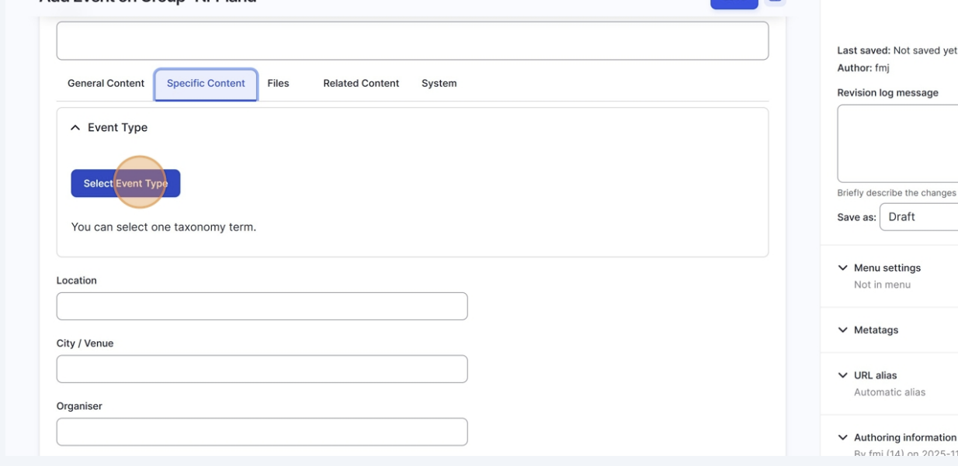
Now select your type of event in the list and scroll down to Select Taxonomies to confirm this choice.

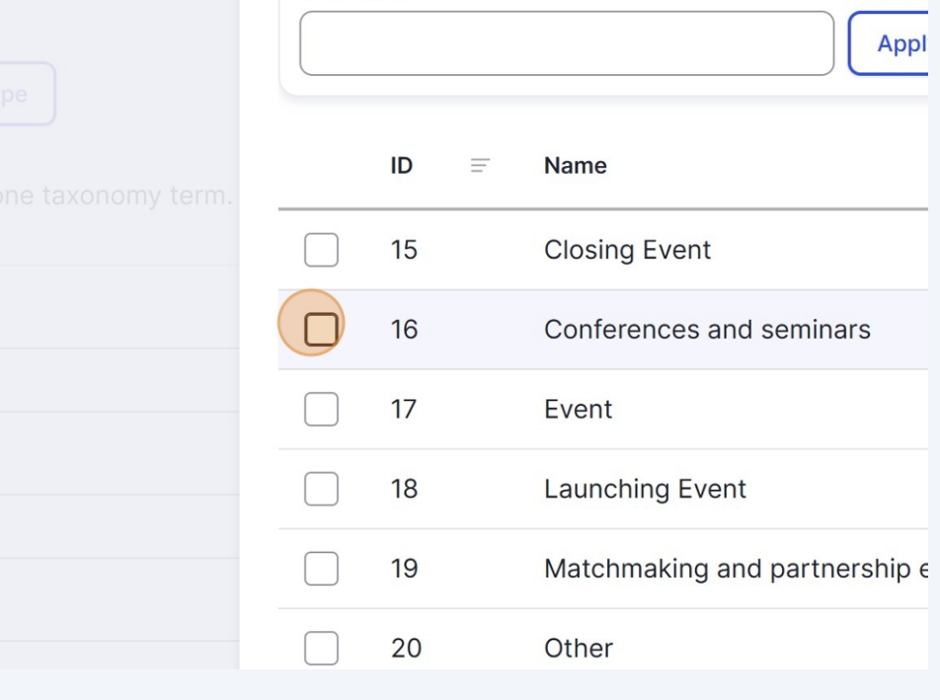 | 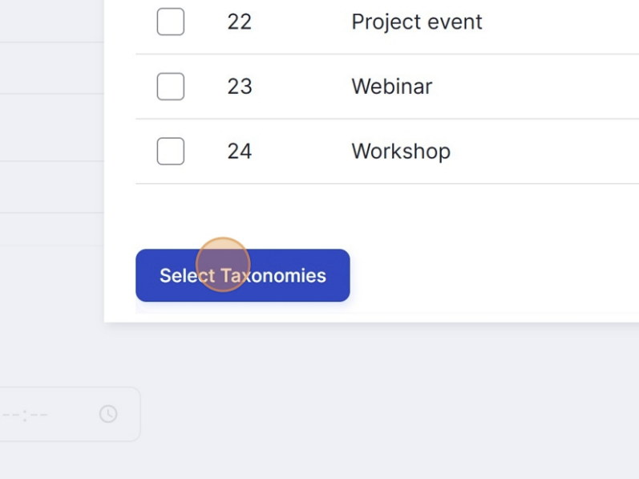

  - Add the location of the event
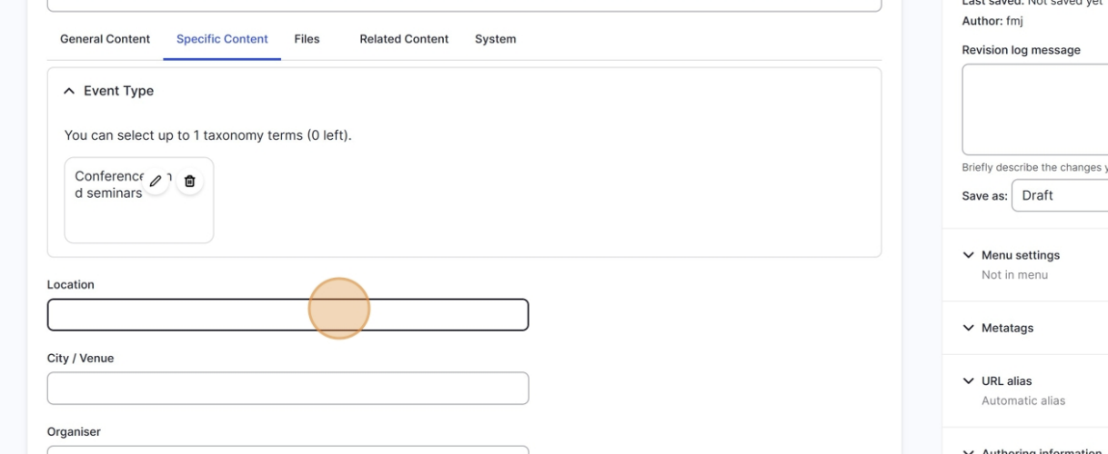
  - Add the city and venue.
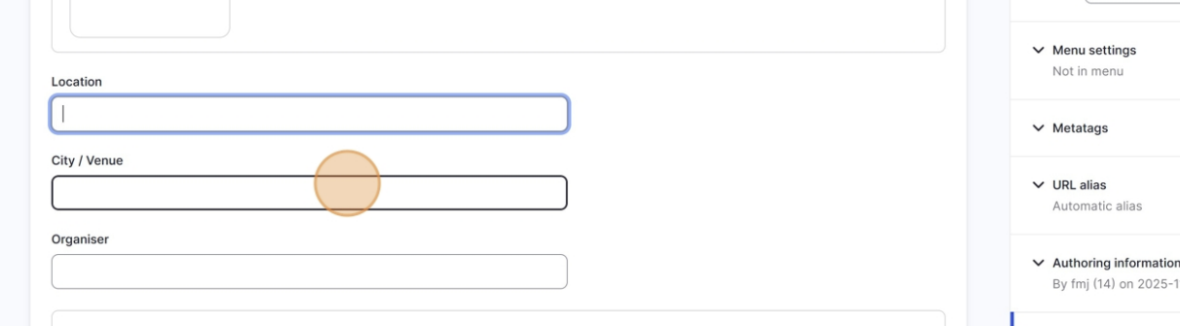

  - Add the organiser

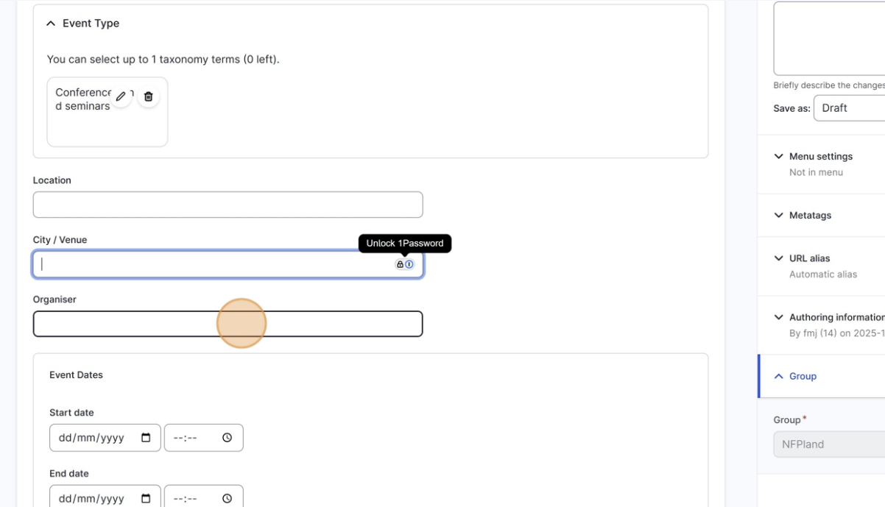
  - Add the dates and times.

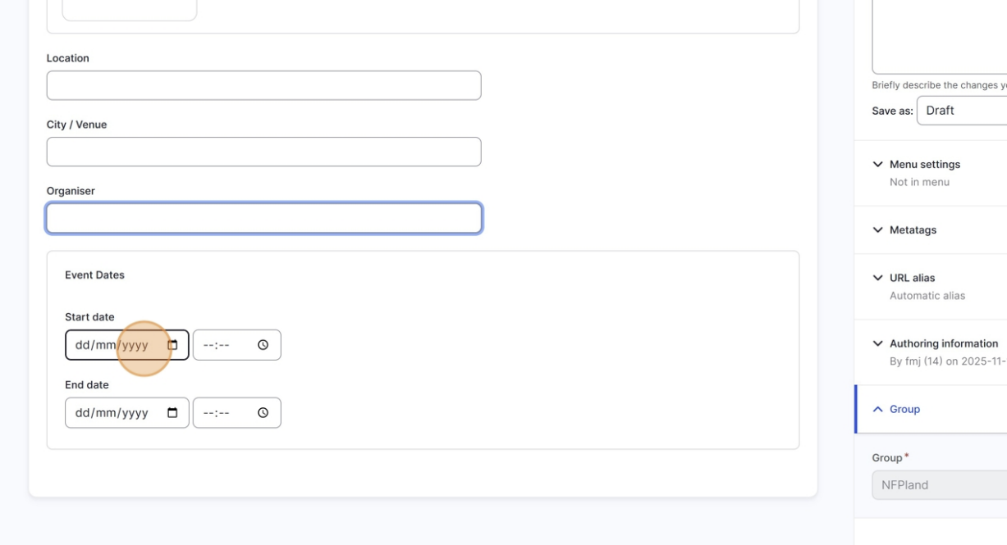

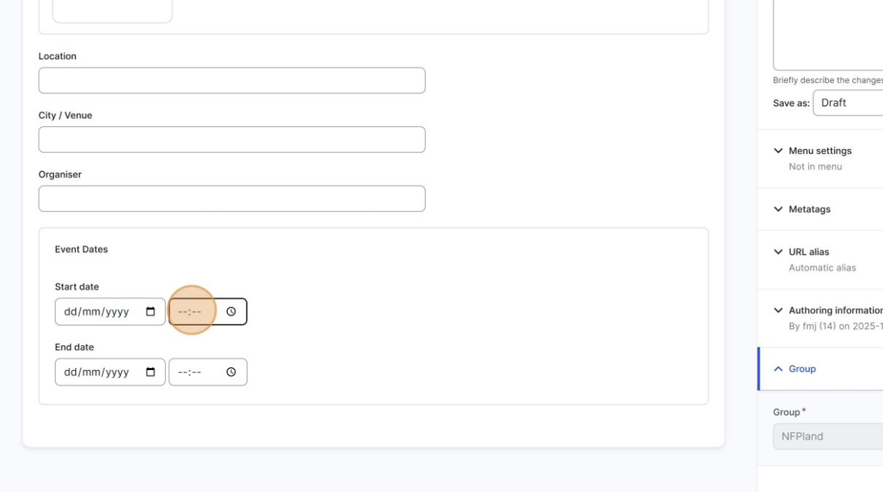
  - Now let’s add an image to the event. Navigate to files.
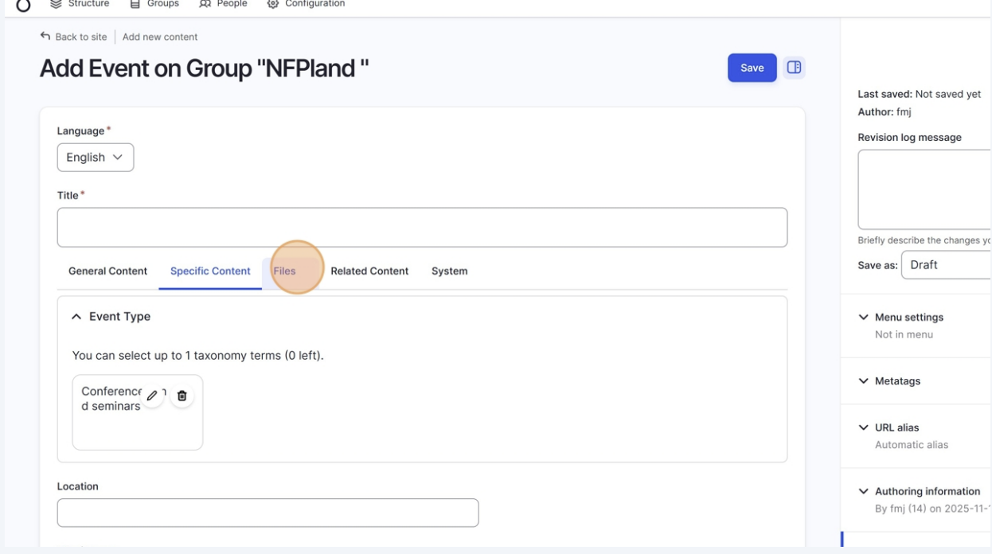

  - Now let’s add an image to the event. Navigate to files.
Select an image, in this example a local main image
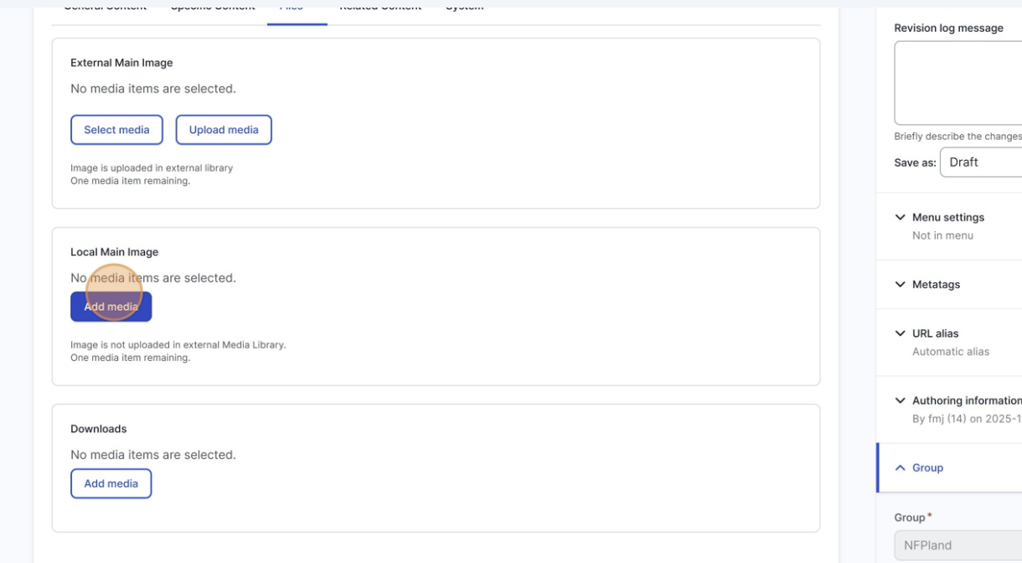
  - OPTIONAL: You can also add related content to your event (programmes, documents, countries, etc.). Navigate to the Related Content tab and select the content you would like to feature.
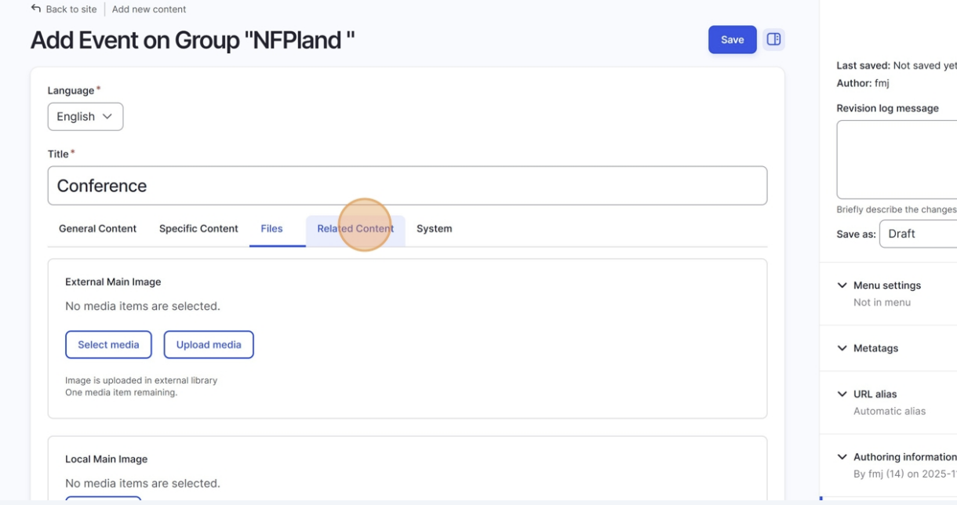

  - Finally, swich the state of the event to Published and click on save in the top.
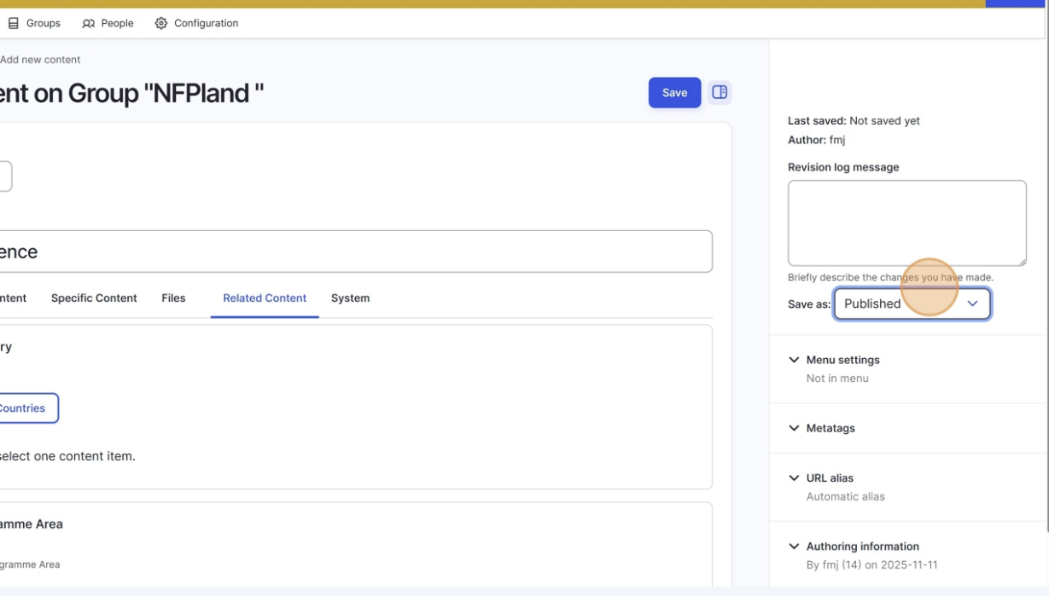

  - HOW TO CREATE A PAGE

Learn how to create a new page on your website, for example an “About”, “Contact”, or any other information page.

1. Go to the Page section
After logging in, open the top menu and click on Add new content
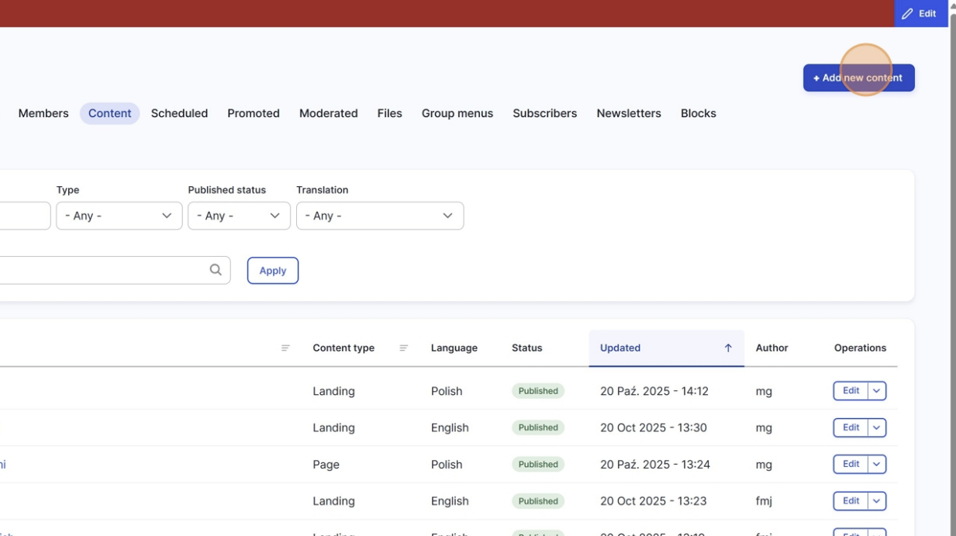
    - Choose PAGE in the content list

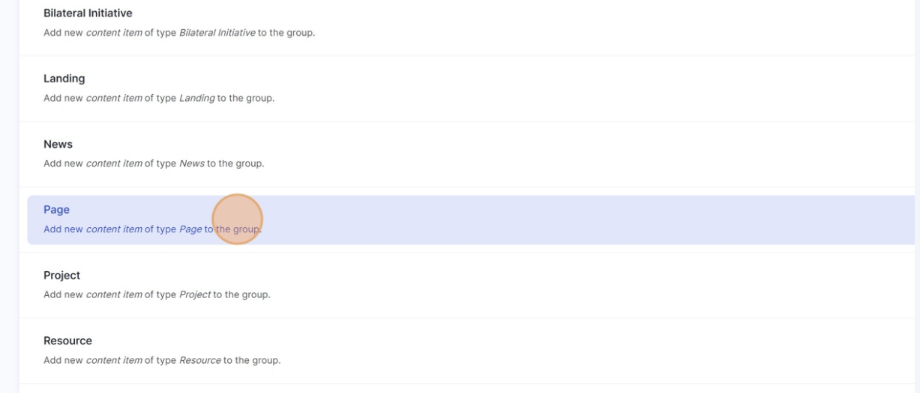

Add your title and main text

In the Title field, write the name of your page (for example: Our history).
In the main Body field, write the text you want to appear on the page.
Use the formatting tools above the text area to add headings, links, lists, or quotes.

You can also add a main image or insert images directly in the text.

- Choose Local Main Image if you want the image to appear only on this page.
- Choose External Main Image if you want to use an image from the Media Library, or if you want the image you upload to also be saved there for future use.

Tip: Use clear headings (Heading 2, Heading 3, and respective styles to them) to make long pages easier to read, it will add a table of content to your page.

Here’s an example of what that looks like: https://eeagrants.org/en/fmo/about-us

f your page includes downloadable files such as the Grants logos, reports or guides, you can upload them by clicking the Add media button in the text editor and selecting the document you want to add.

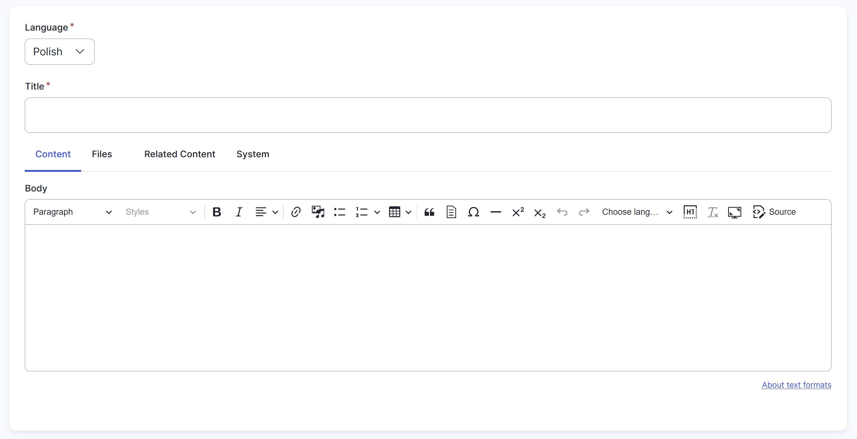

    - Menu settings (optional)

If you want your page to appear in the site’s main menu:
- Open up Menu settings on the right.
- Tick Provide a menu link.
- Enter the link name (for example: About the Fund).

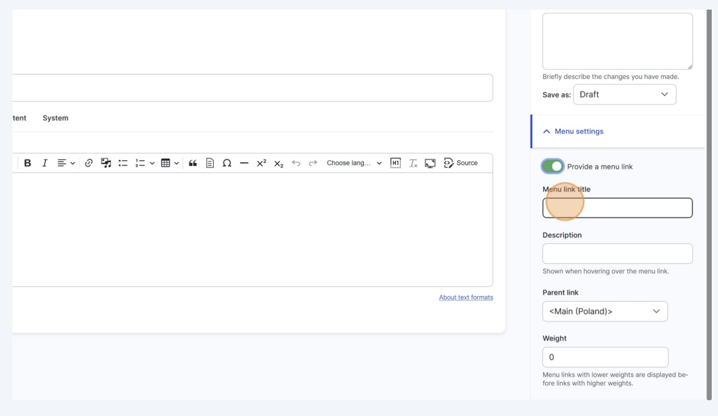

    - Add alternative text and captions

If you add images, remember to include Alternative text (required by the system) and add or translate captions when needed. Captions will appear below the image on the published page.

7. Translate your page
Once the English (or original) version is saved, you can add translations:
- Open your page.
- Click the Translate tab.
- Click Add translation next to the language you want to add.
- Enter your translated text and save.

The system will automatically display the correct version based on the visitor’s language selection.

8. Save and publish
When you’re ready, scroll down and click Save.

  - HOW TO ADD ITEMS (PAGES, etc) TO YOUR THE MENU

Learn how to add existing content to your site’s main menu directly from the menu settings in Drupal.

- Open the menu section
From the top administration bar, go to Groups menus
This is where you can manage all the links that appear in your site’s main menu.

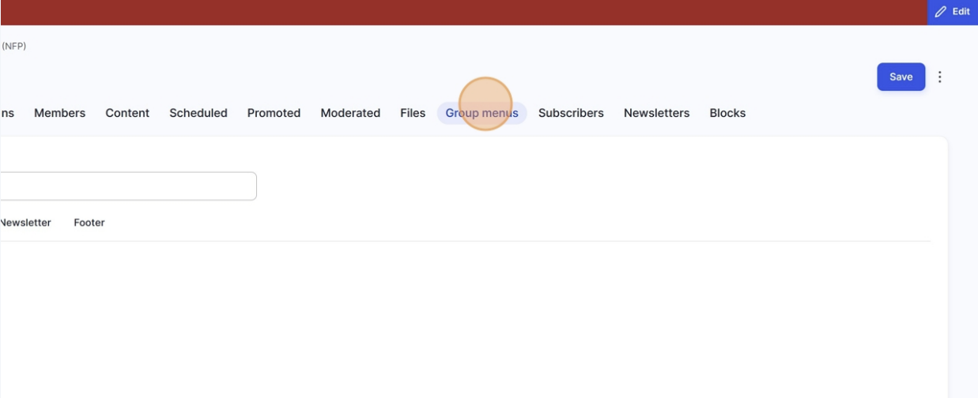

- Click on Edit to access the menus’ editing page
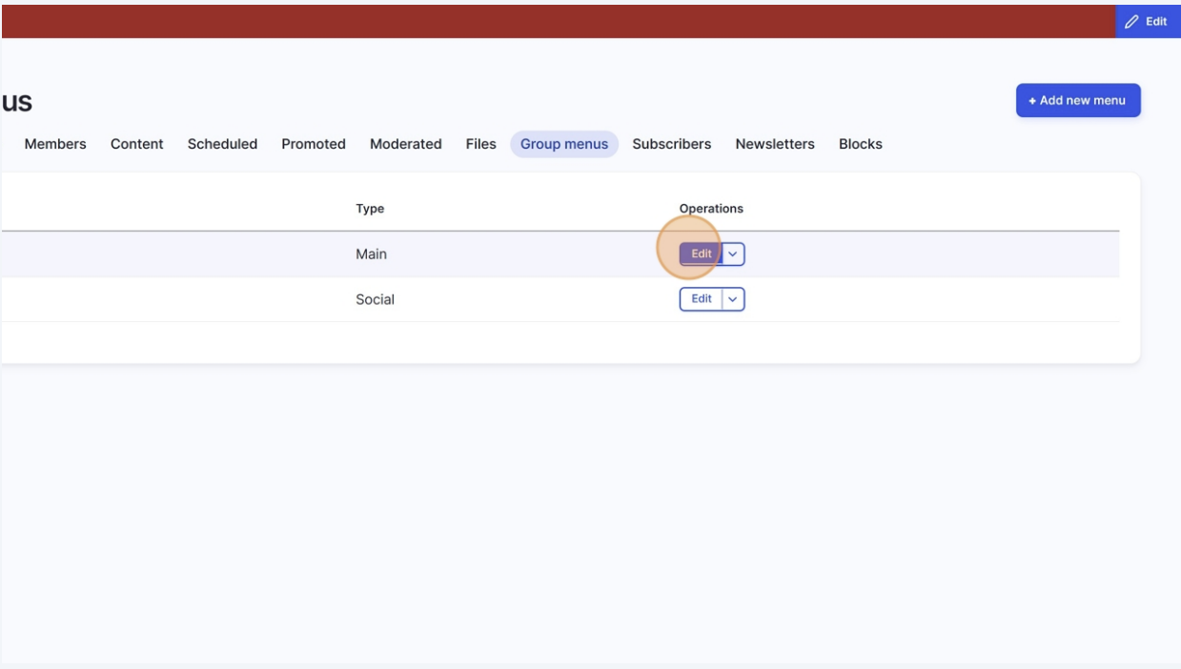

- Click on + Add link to add a new link to your menu

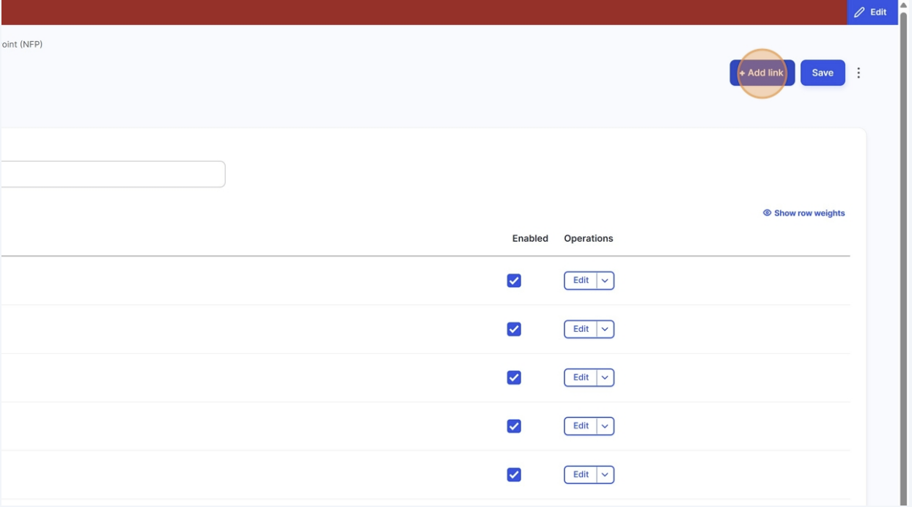

- Name your link (this name will appear in your menu

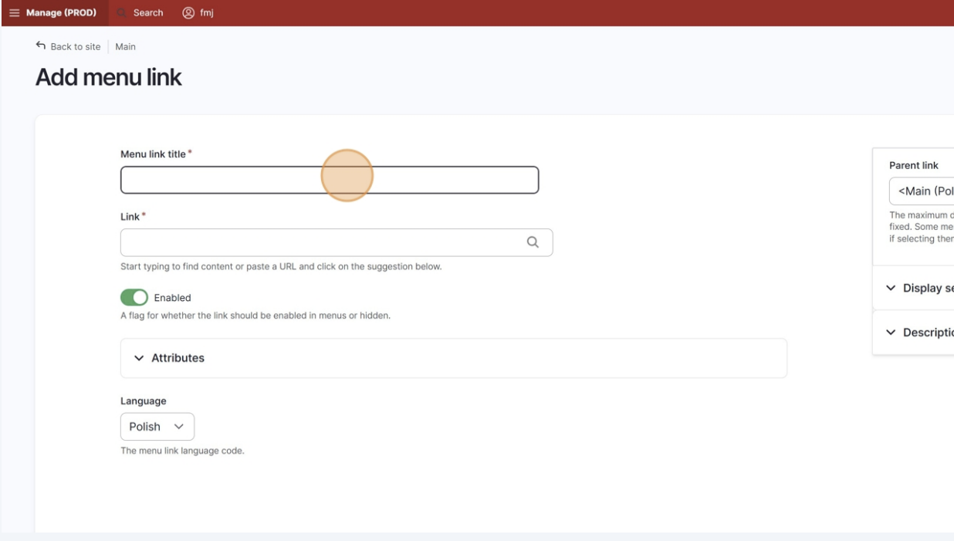

- Add the URL of the page you want your link to point to. This can be an internal page, and in that case the name of the page should automatically appear when you start typing it. If it’s an external URL, just make sure to include the full URL.

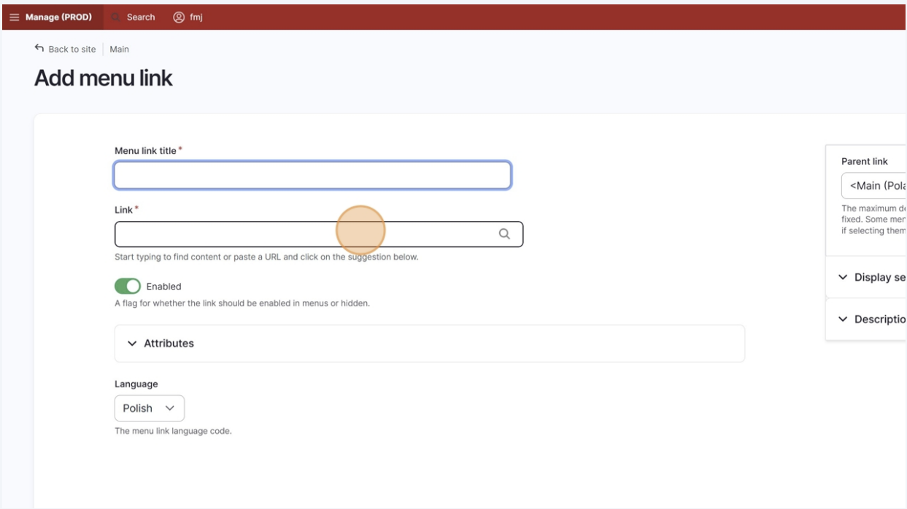

- Click on Save to save this.

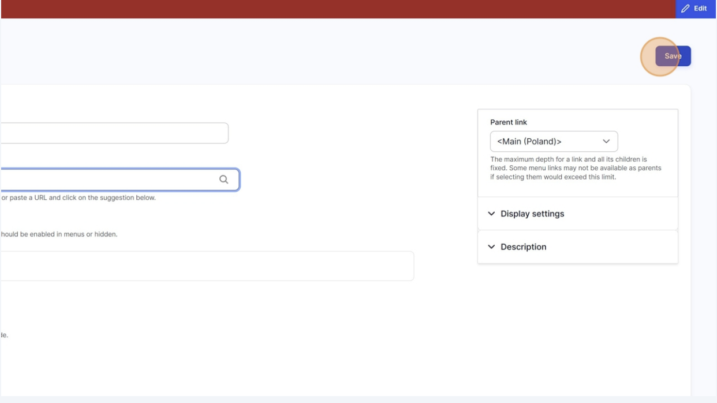

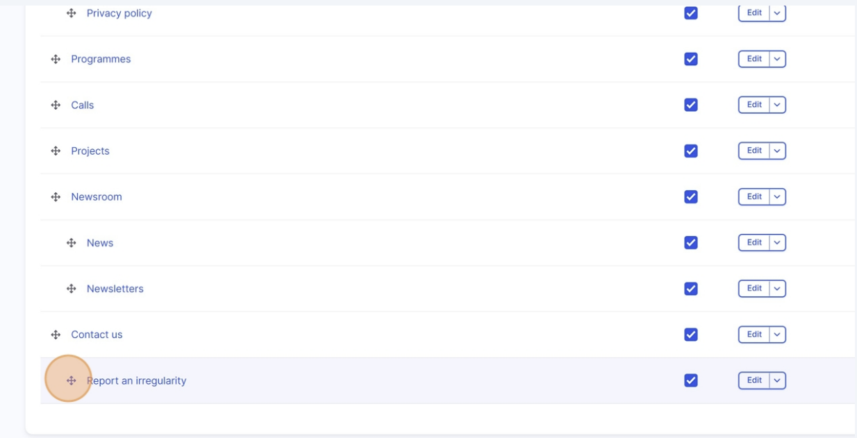

- You can now adjust the order
You can drag and drop menu items to change their order. Moving it slightly to the right adds it under the item just over it (as a sub-menu item)
Click Save when you’re done arranging the menu.

- Save and check

Click Save to confirm your new link.
Visit your website and check that the new item appears in the menu and links correctly to the page.

- ADD DOCUMENTS TO YOUR LEGAL FRAMEWORK

What this page does
The “Legal Framework” is a predefined view that auto-lists documents based on their Resource type.
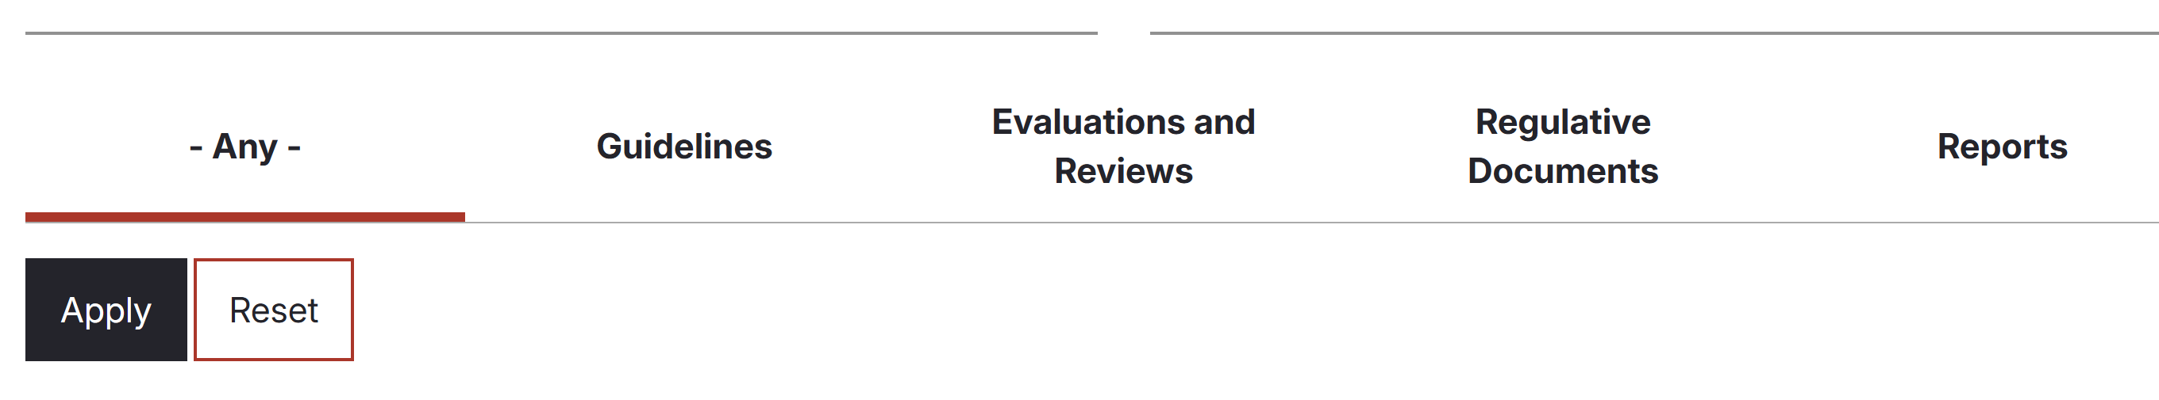
The tabs you see on the page are driven by Resource type taxonomy (parent terms) and appear as tabs on the legal framework page.
  - Evaluations and Reviews
  - Guidelines
  - Regulative Documents
  - Reports
  - Other
  - Plus an “Any” tab that shows everything matched.

Each of these “parent” terms also have tags under them for more precise tagging if needed.

Evaluation and reviews
Guidelines
Factsheets
Grace User Manuals
Regulative Documents
Agreements
Memoranda of understanding
Programme agreements
Regulations
Strategies and policies
Reports
Annual Reports
Fraud and irregularities reports
Other
Visual identity

If a document isn’t tagged with one of these five Resource type parents (or their children), it won’t appear.

Now let’s upload a document to your website.
  - Navigate to the content tab in your dashboard.

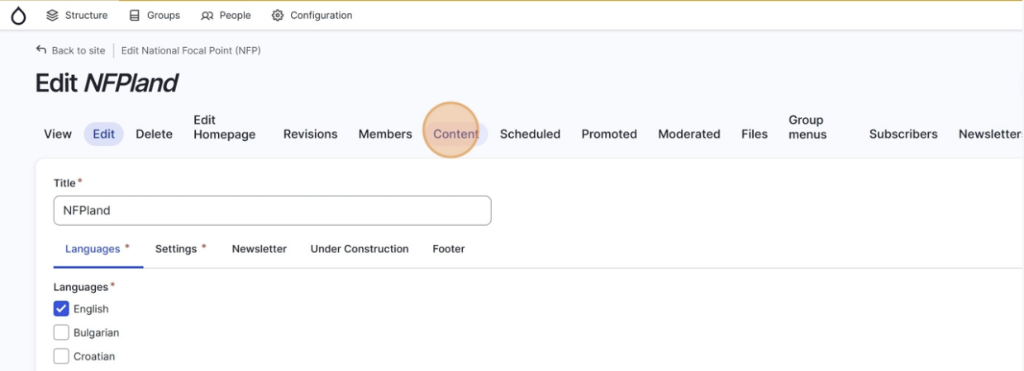
  - Click on add new content
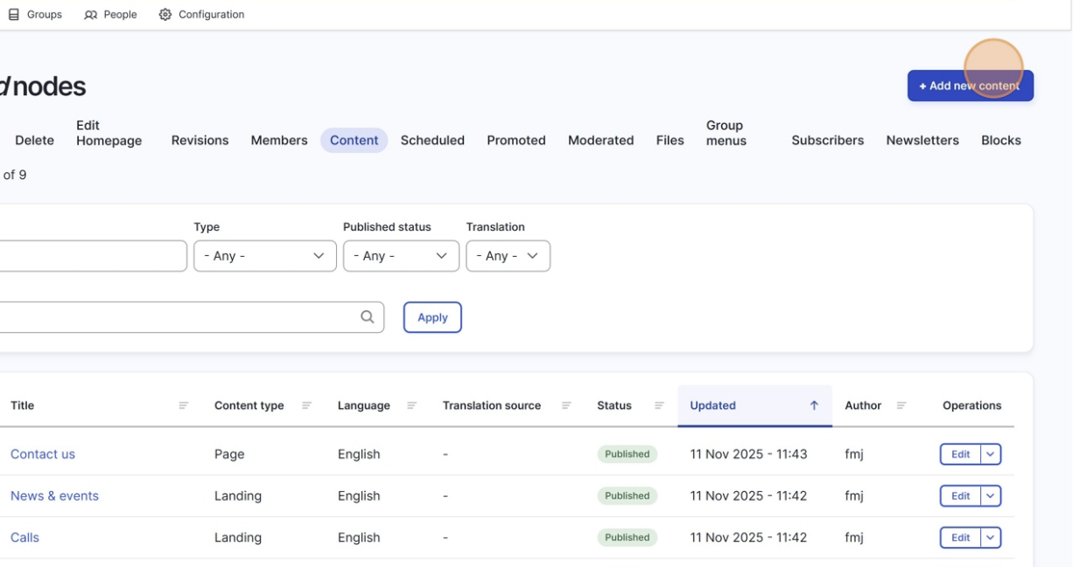

  - Click on Resource
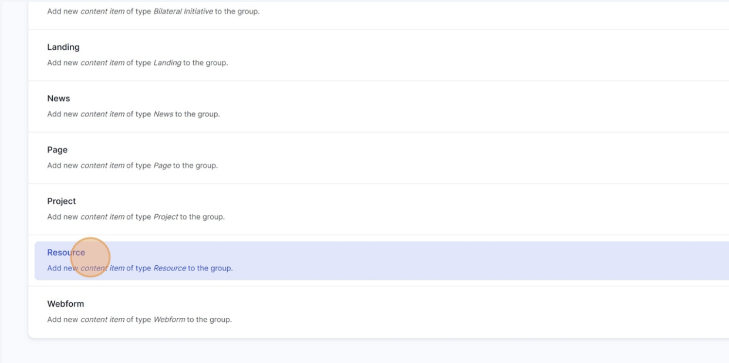
  - Write the title of your document (this will be the name of the document shown on your website)
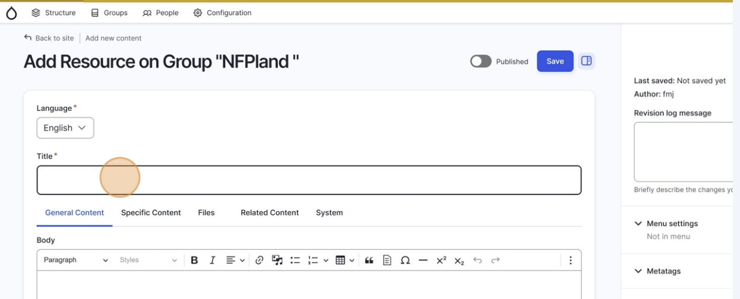

  - OPTIONAL: Add a description (this will be the description of the document shown on your website).

Use this space to describe your document and also to link to other resources, documents or versions of the documents, relevant to your readers. For example, if this is a translated version of your document, you can use the description here to point readers to the original version of the document.

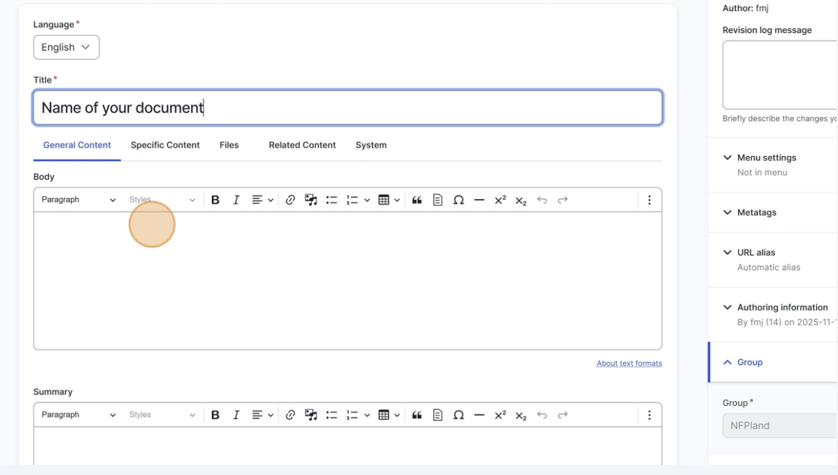
  - OPTIONAL: Add a summary (this will be a short sentence shown next to your document when listed in your documents list on the website – to give readers a quick idea of what it is before the click on it and open the document page itself and read the full description).
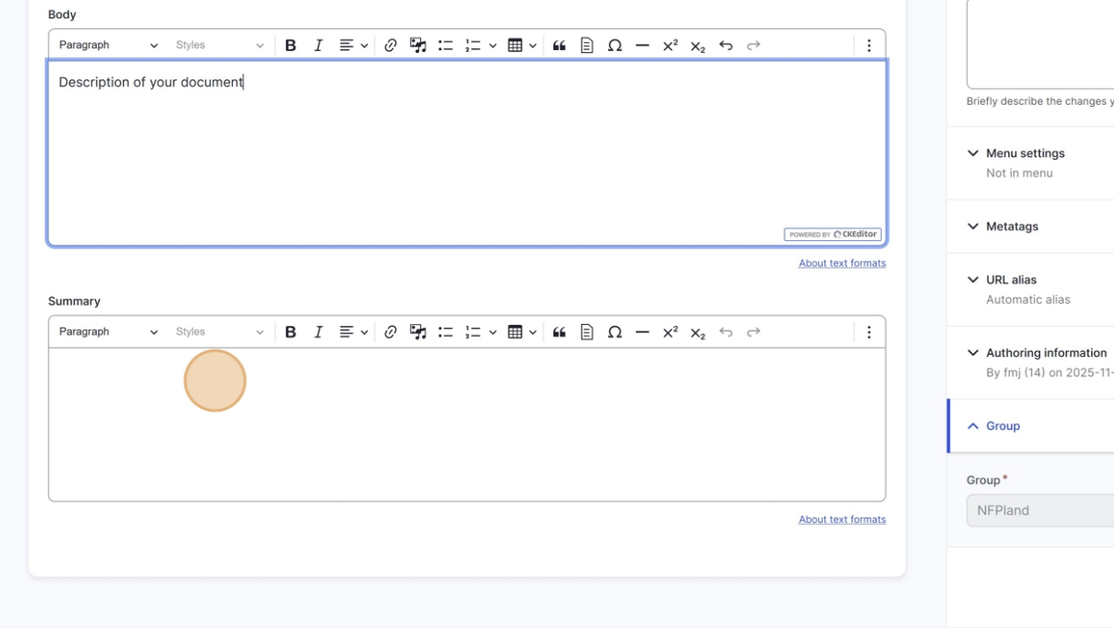
  - Now let’s add a type to your document, like mentioned in the start of this chapter. These can be:
- Evaluations and Reviews
- Guidelines
- Regulative Documents
- Reports
Click on the specific content tab.
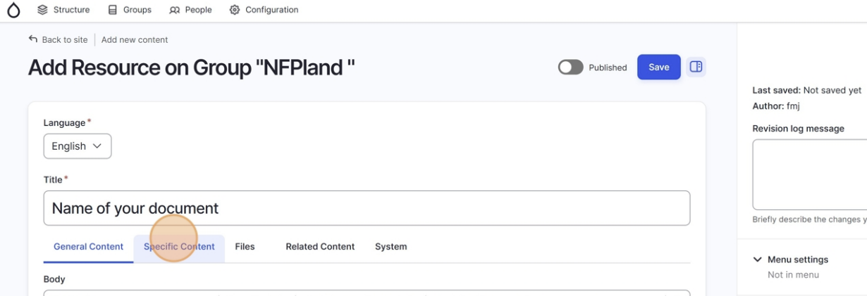
Now select the resource type.
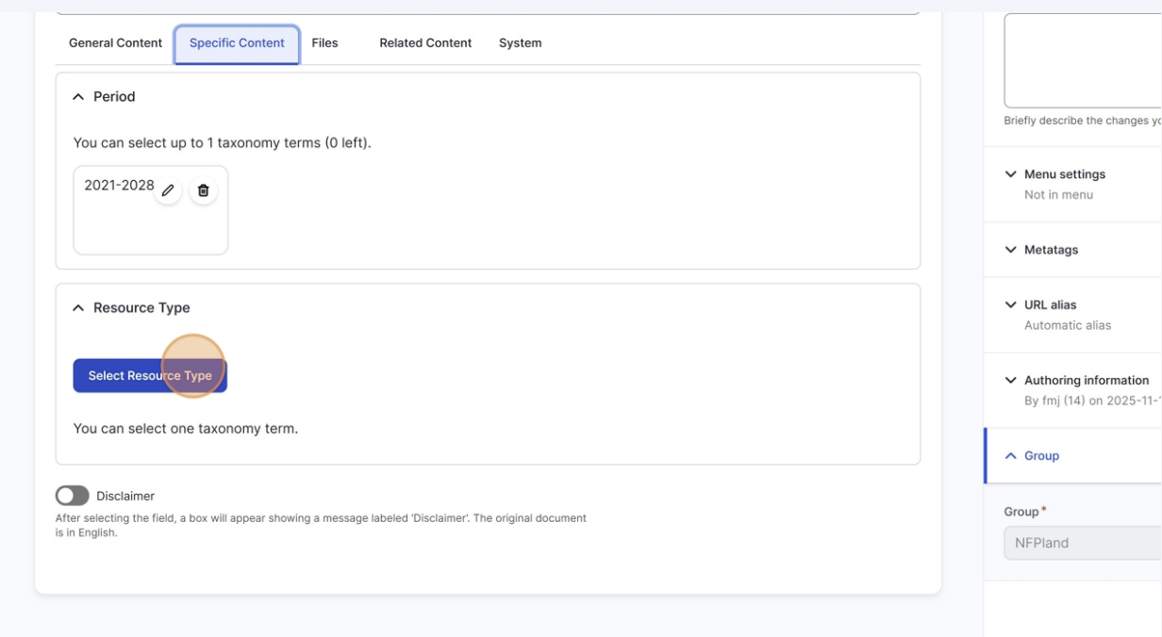
You will now see a list of different types, select the relevant one and then scroll down and click on select taxonomies.

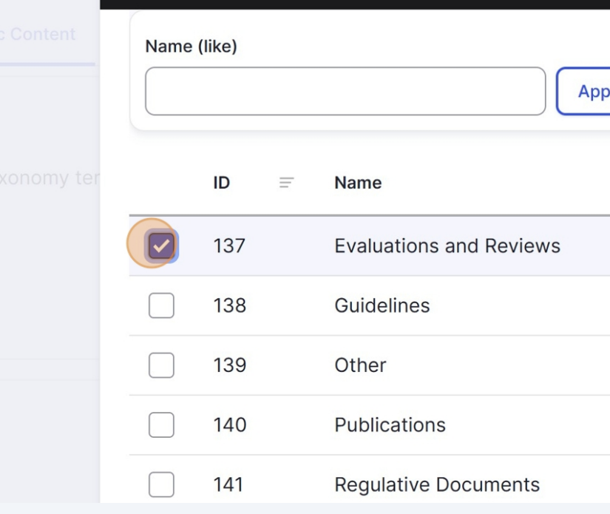 | 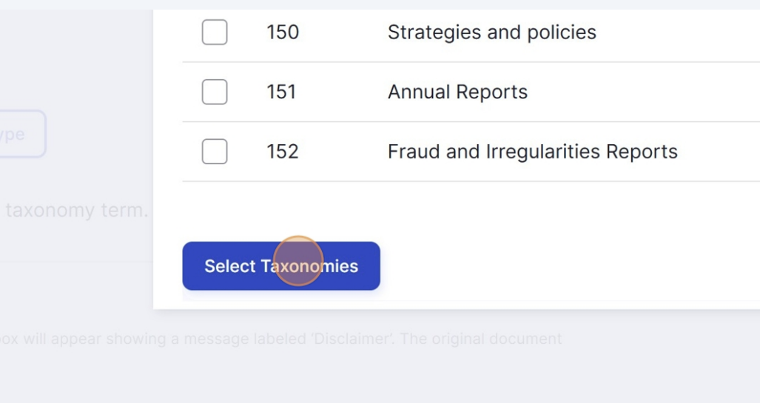

  - Now let’s upload your document to the website and select its language. Start by navigation to the files tab.

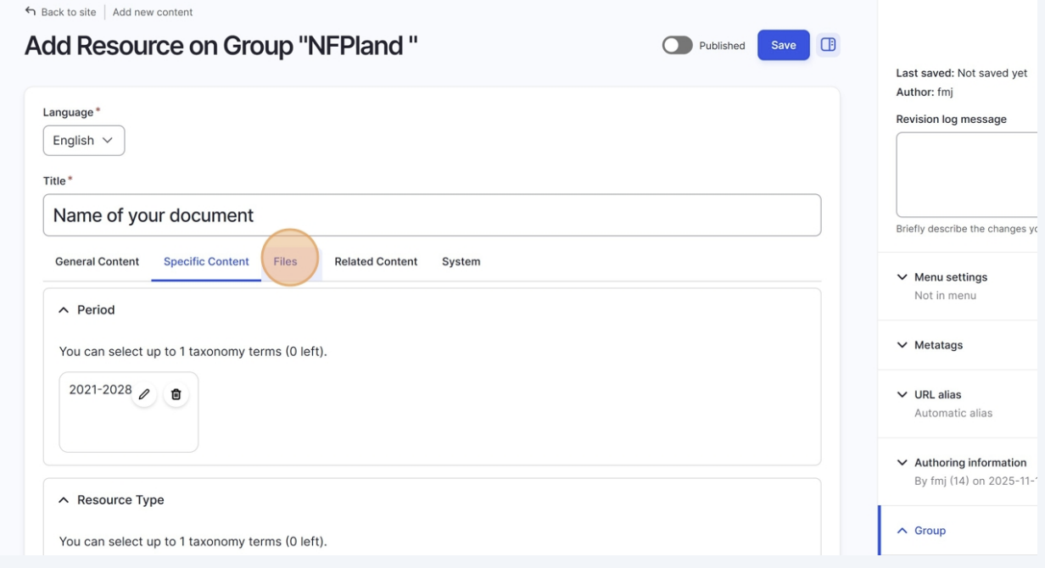

Click on Add media

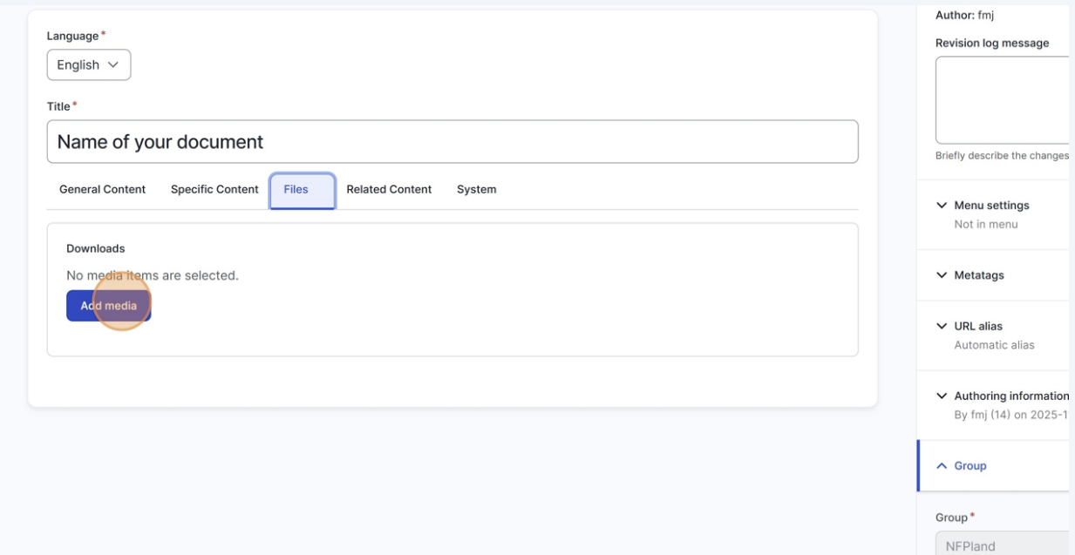

When prompted, click on Choose files and navigate to the file you’d like to upload.
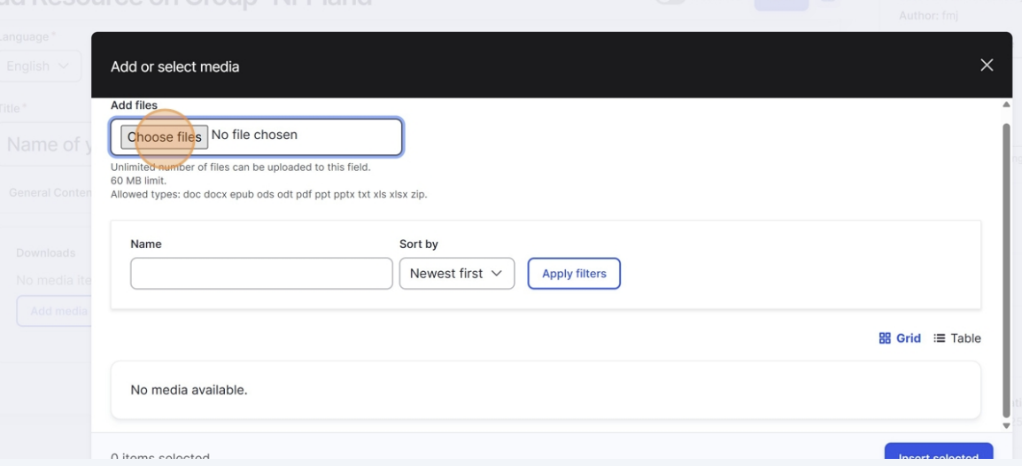
Once you have inserted the file, let’s tell the system what language the file is in, so it can be displayed the right way on your website.

Click on language to open up the options.

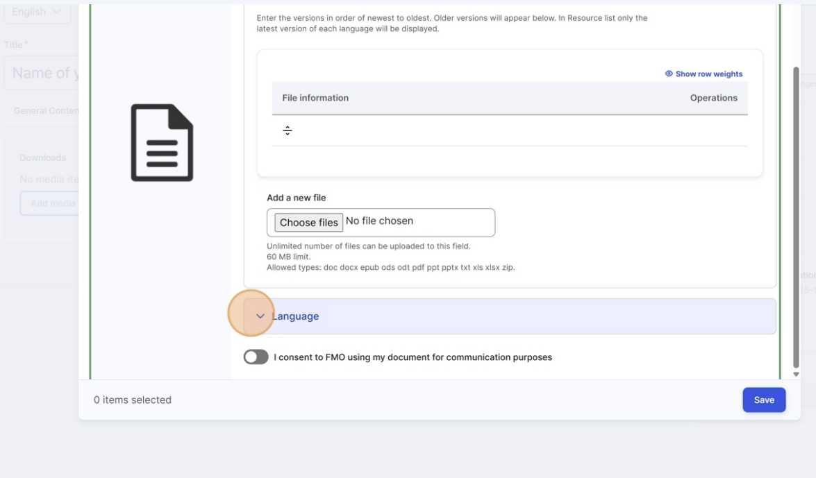
Click on select entities to show the different languages.
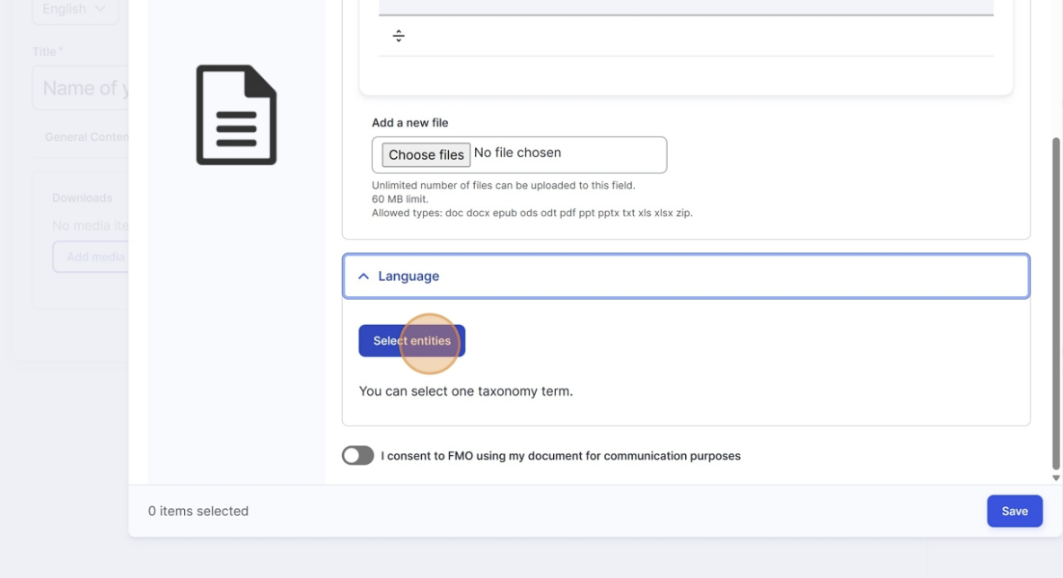
Select the right language for the document, and then scroll down and click on select taxonomies to confirm your selection.
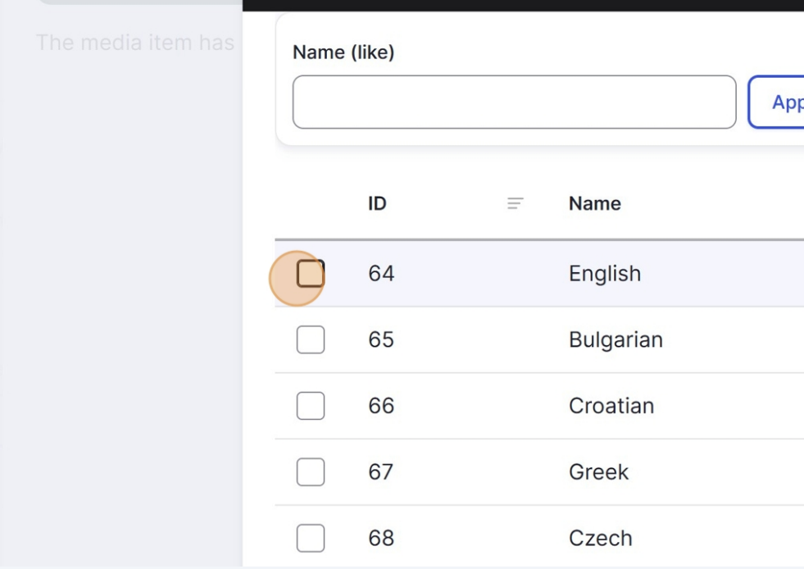 | 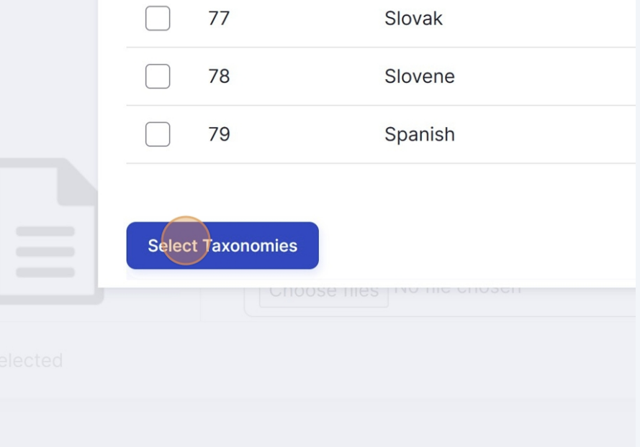

  - The file has now been added to the system, you will now insert it so it is shown on your website.

Click on insert selected.

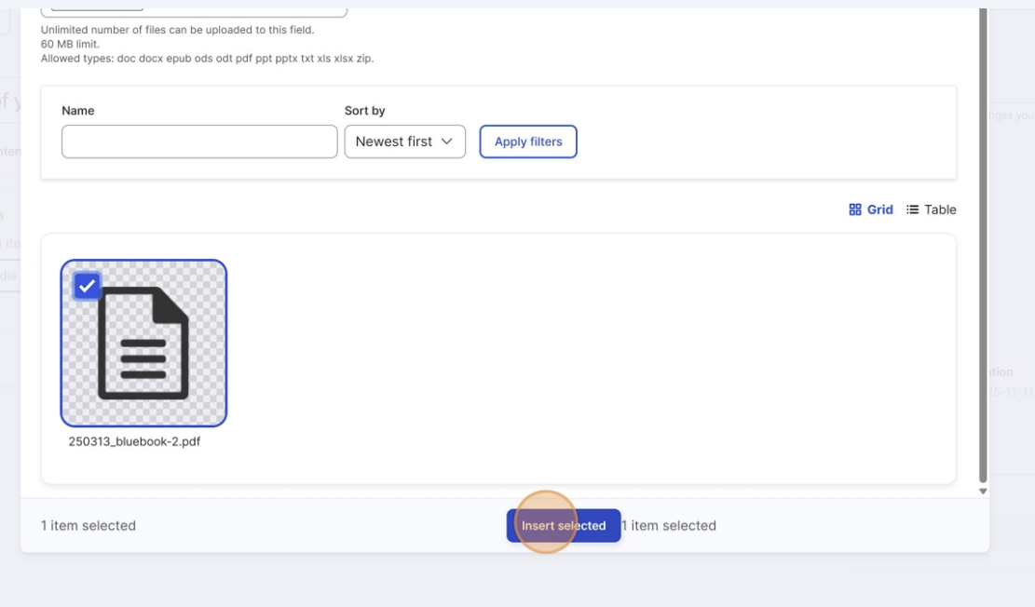

  - You can add related content to your documents (such as programmes, news articles, other documents, etc)
Click on the Related Content tab and select the type of related content you would like to display.
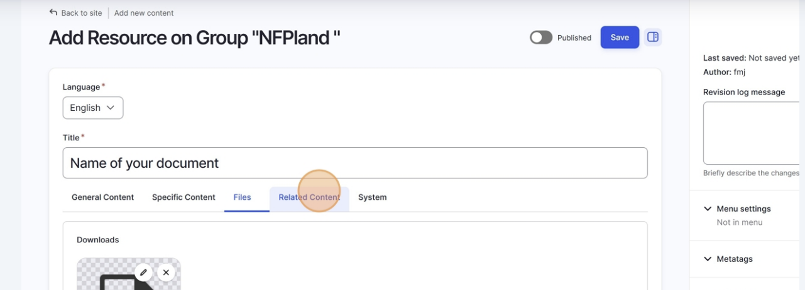

  - You have now added a file and tagged it correctly, let’s publish it. For that, all you have to do is to flip the Published swith and click on save.
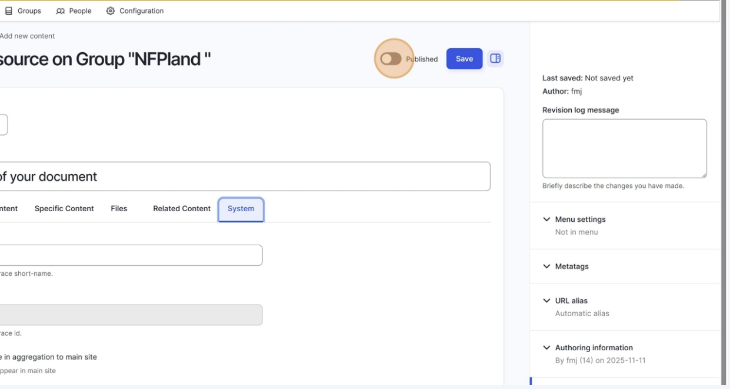

- HELP AND SUPPORT

For any technical issues, please reach out to: mulitisitesupport@efta.int
For any improvement suggestions or ideas, please reach out to: bettermultisite@efta.int

