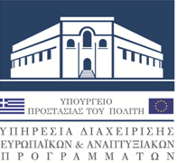
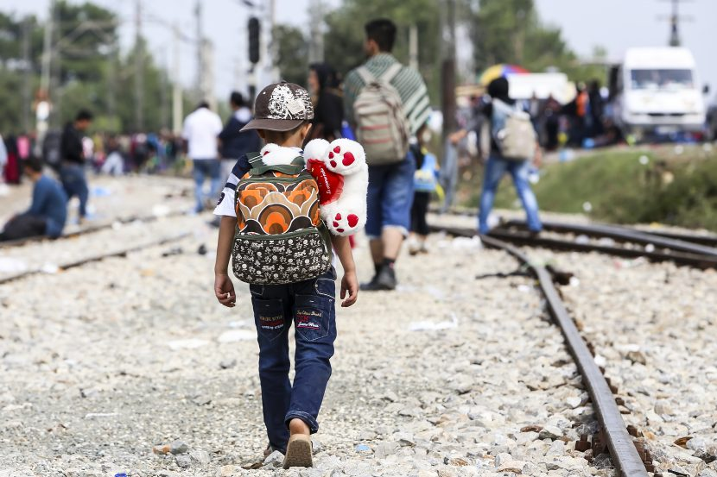

EEA GRANTS 2014-2021: Signature of the Project Contract for the Predefined Project entitled "Predefined Project 8 – Enhancing the capacity of the Special Secretariat for the Protection of Unaccompanied Minors (SSUAM) to evaluate the quality of services provided to unaccompanied minors within the Accommodation Centers”.
In the context of the European Economic Area Financial Mechanism 2014-2021 (EEA Grants), European and Development Programmes Division of the Ministry of Citizen Protection, acting as the Programme Operator of the Programme GR-G "Capacity Building of National Asylum and Migration Management Systems", signed the Project Contract for the Predefined Project entitled "Enhancing the capacity of the Special Secretariat for the Protection of Unaccompanied Minors (SSUAM) to evaluate the quality of services provided to unaccompanied minors within the Accommodation Centers”.
The project budget is 1.596.078,00 EUR and it will be implemented by the Special Secretariat for the Protection of Unaccompanied Minors (SSUAM) of the Ministry of Migration and Asylum. The implementation of the predefined project aims at the improvement of the social care towards asylum seekers via the establishment of standard operating procedures of social care for unaccompanied minors and vulnerable groups.

In particular, the Project aims towards the establishment of a system of evaluation and supervision of the services provided in the accommodation structures of unaccompanied minors and other vulnerable groups of immigrants, through the following activities:
• Development of an interactive electronic evaluation platform, manuals and guidelines for the process,
• Development of National Standard Operating Procedures, manuals and guidelines for the operation of the accommodation structures,
• Development of questionnaires and proposals for the standardization of the quality criteria of the relevant structures,
• Implementation of capacity building activities for the personnel of the accommodation structures and the personnel of the Special Secretariat for the Protection of Unaccompanied Minors of the Ministry of Immigration and Asylum.
The Project will be implemented in partnership with the Norwegian Directorate of Immigration (UDI) which acts as the Donor Project Partner.

